Activity 3: Visualizing Demand
Team Name:
Team Member Names:
Purpose:
- Run the Jupyter Notebook and enter the known user type information (using interactive tools) to explore energy consumption and power demand for the 10 selected user types.
- Create plots that summarize daily energy consumption.
- Create plots, tables, and export data outputs that summarize daily power usage, which will be utilized in Activity 4.
- Analyze the plots, tables, and data to get a better understanding of the energy and power data.

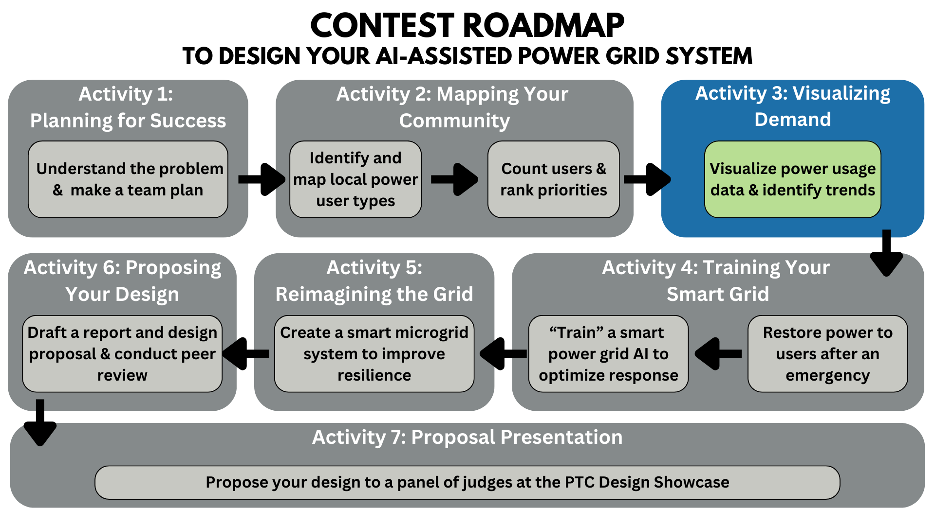
Activity Tutorial: https://www.youtube.com/watch?v=pg5ppjvizik

Overview:
Now that you have mapped your community and identified 10 different types of power users, you will explore their daily energy consumption to understand how much energy must be allocated to maintain typical operations, by using a Jupyter Notebook to access existing data sets. In our datasets available through the Notebook, there are 19 different user types available for you to choose from. If a user you are interested in is not available among the data sets, you will have to choose an available set to approximate your other users.
STEPS 1–6: Using the Jupyter notebook found in the Activity 3 folder, you will select 10 user types and output plots of their energy usage over a 24-hour period. The plots will be saved to your folder in NanoHUB as a “.png” image file for you to download.
STEP 7: After reviewing the energy plots, you will examine the daily power demand of each user type to understand how individual usage compares to the total grid demand.
STEPS 8–9: In the Jupyter notebook, you will enter the number of buildings in your community for each of the 10 selected user types, and the notebook will calculate the total power demand for those buildings (the energy plots did not factor in the number of buildings per user type). You will use the Notebook to generate an Excel sheet and containing the 24-hour power data for all of your users as well as your total grid. The Excel sheet will be saved to your folder in NanoHUB as a “.xlsx” image file for you to download.
STEP 10: Then you will use the Notebook to generate 24-hour plots showing both individual user type demand and the total grid demand, allowing you to see the scale of contributions across users. The plots will be saved to your folder in NanoHUB as a “.png” image file for you to download.
STEP 11: Finally, you will output a table that reports the maximum power usage of each user type, the time at which it occurs, and its percentage contribution to the entire grid’s total maximum power. The plots and tables will be saved to your folder as a “.png” image file for you to download.

STEP 1: Launch Jupyter Notebook + Upload Files
Start by accessing the Jupyter notebook on a service called nanoHUB, where you can launch the activity 3 notebook as a “tool”.
- First, you need to create a free nanoHUB account at the link here: nanoHUB registration
  - You only need to fill out the "Required" sections on the registration form and you can use your google account to register if you would like.
  - If you can NOT access nanoHUB please ask your teacher if they can access the website or reach out to your mentor and schedule time for them to run the programs on your behalf.
- After you have created your account, you can open the Jupyter notebook tool (as seen in Figure 1 below) by searching for “Jupyter Notebook (202105)”, or clicking this link: Link to Jupyter Notebook Tool on nanoHUB
- To open the Jupyter Notebook program, click “Launch Tool”. You will see the Jupyter notebook “Home” page also known as the Jupyter file explorer.
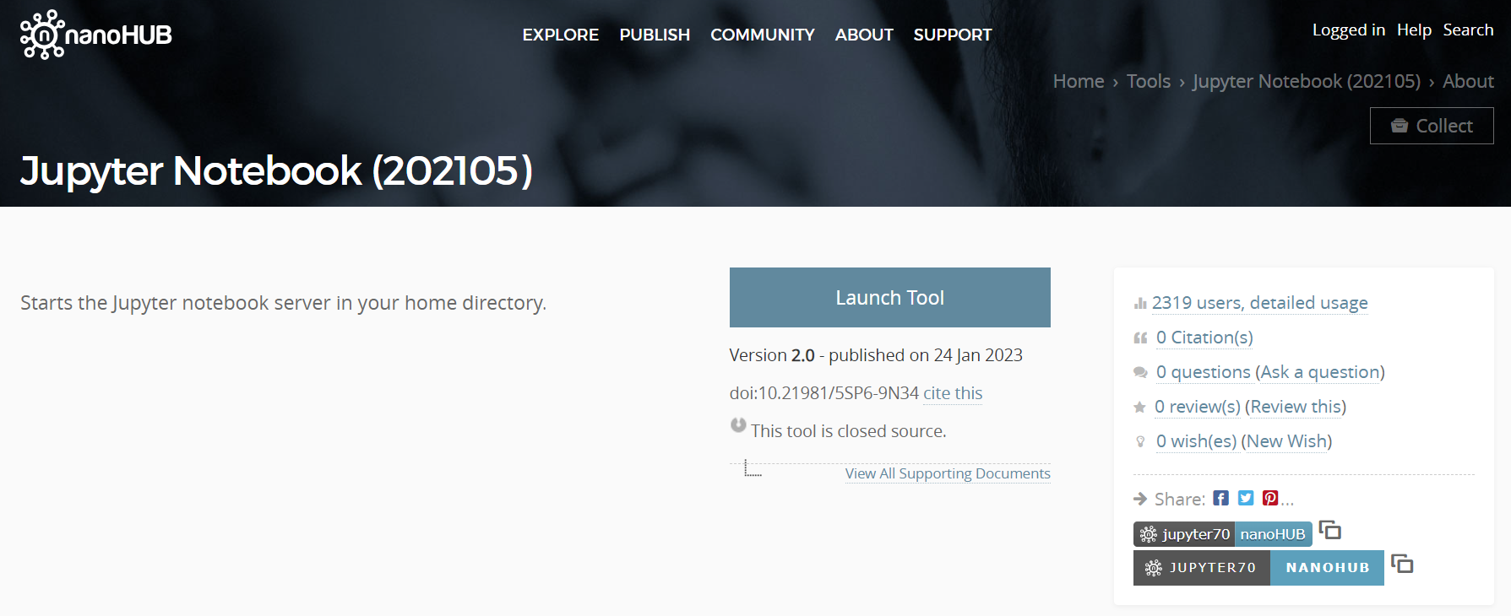
Figure 1. Jupyter Notebook Tool Page

STEP 2: Open the Jupyter Notebook
Now you can use the Jupyter notebook specific to this activity to output the plots, tables, and data associated with the energy consumption and power demand of your 10 user types to complete this activity.
- Upload the “all_users_energy.csv” file you downloaded from Teams into the Jupyter Notebook file explorer.
- Upload the notebook (.ipynb) file that you downloaded from Teams into Jupyter Notebook (see Figure 2). First click “Upload” in the top right corner, select the file, then click “Open”. You will be prompted to click “Upload” again on the file at the top of your file explorer (home page). The file name will appear in the file explorer. Click on it to open the Notebook.
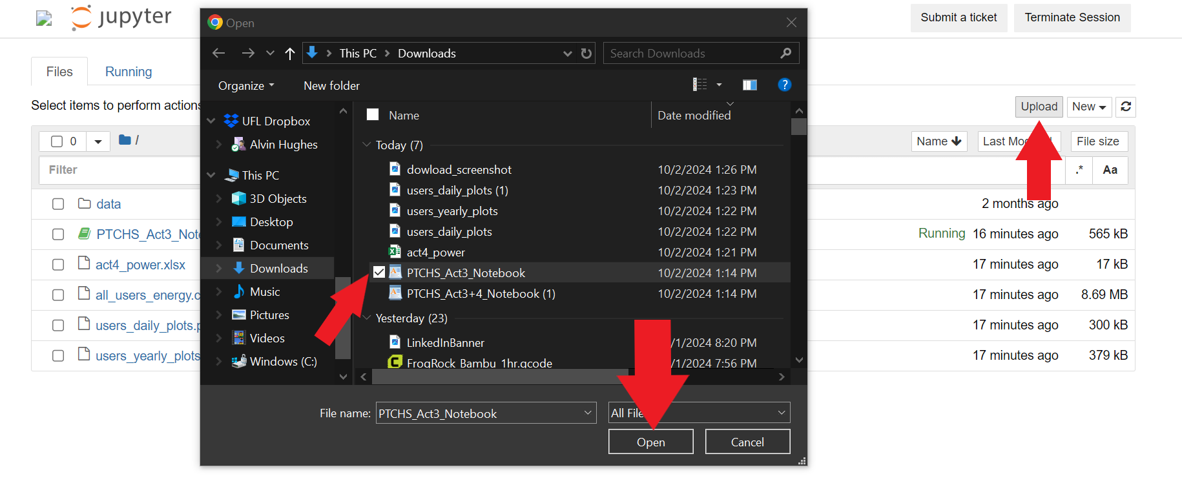
Figure 2. Uploading the Notebook to Jupyter on nanoHUB

- Once you open the file, the notebook should open in another browser tab for you to view and utilize to complete the activity (see Figure 3).
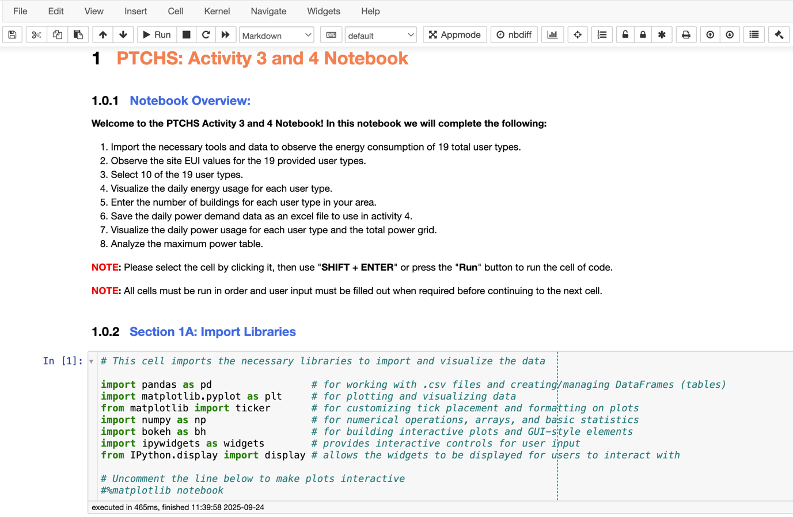
Figure 3. Activity Notebook Overview

Important Note:
- When referring to different sections of the notebook, we will be referencing the titles in blue, such as “Section 1A: Import Libraries”, and not the number in front “1.0.2”.

STEP 3: Learn How to Run the Jupyter Notebook
- Within the notebook there are “cells” containing code for you to run/execute. To run a cell in this notebook, click to the left of it to select it. When a cell is selected, it will be outlined in blue, and you can press “Shift + Enter” or click the “Run” button to execute it. After running, the next cell below will automatically be selected. Figure 4 shows an example of a selected coding cell in “Section 1A: Import Libraries”. If you click inside a cell, it will be highlighted in green which means it’s in edit mode. You should avoid making changes to the code itself; so it’s best to ensure cells remain highlighted in blue before running them.
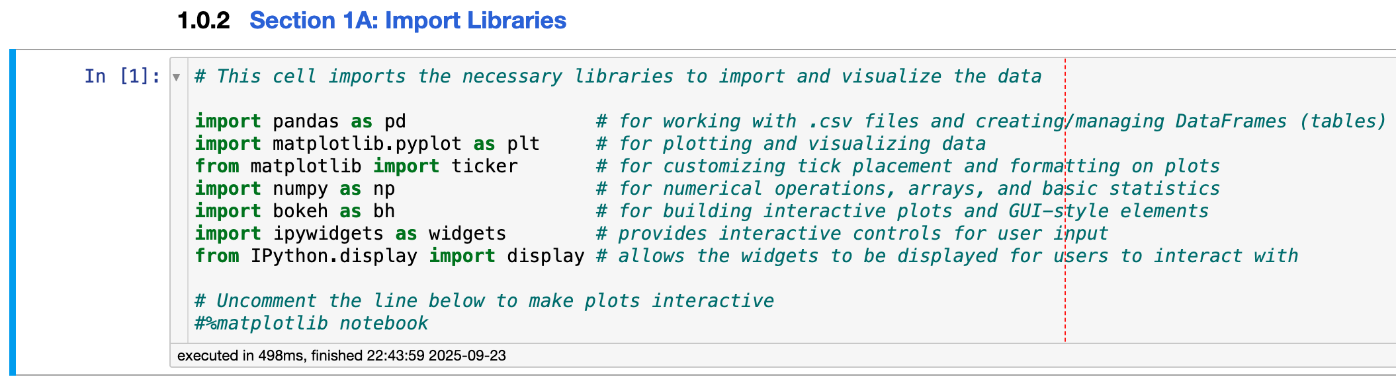Figure 4. Section 1A Coding Cell Selected and Executed
Once a cell is run in general, the duration of its execution and the time it finished running will appear directly below it. Also, a label will display “In [n]” in the top left, indicating the order in which the cells have been executed.
In the example shown in Figure 4, it displays “In [1]”, implying that this was the first cell run out of all cells. Once another cell is run, it will display “In [2]” unless you rerun the first cell again. Tracking these numbers helps you see when changes have been made to a previous cell(s) but have not yet been reflected in the cells below it. If a cell displays “In [*]”, it means the cell is currently running, either because the code is taking time to execute or it’s waiting for user input to complete.
Important Notes:
- While cells in a Jupyter notebook can typically be run in any order, for this particular notebook, please make sure to run all cells sequentially from top to bottom.
- If you re-run a previous cell to update any user type inputs, make sure to also re-run all subsequent cells in order to incorporate those changes.

- Alternatively, you can click “Cell” in the toolbar at the top and select “Run All” to execute every cell in the notebook. However, this can cause issues because the notebook includes interactive widgets for you to input user type information. If you use “Run All”, the notebook will attempt to execute the cells below the widget (before you’ve even entered your inputs) which causes the cell below the widget to throw an error message that stops the remaining cells from running.

If you still prefer to run all the cells at once, first enter your user type information in the widget, then click “Cell” in the toolbar at the top, and then click “Run All Below” to run all the cells below the current cell you have selected (see Figure 5). To avoid potential errors, the recommended approach is to manually run each cell individually in order from top to bottom.
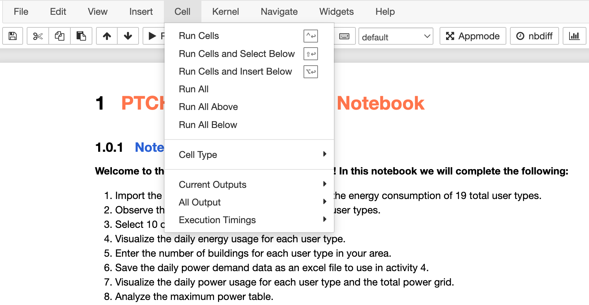Figure 5. Toolbar “Cell” Options

STEP 4: Importing Tools and User Type Data
- Run the cells in “Section 1A” and “Section 1B,” as they are required for the code in later sections to function properly.
“Section 1A” imports the tools you will use to explore the data through tables and graphs, while “Section 1B” loads the energy consumption data for all possible user types and creates a dictionary that maps the formal user type names to the informal names found in the energy data (.csv) file.
Important Notes:
- If you clicked “Run All”, the notebook will execute all cells until it reaches “Section 2”, where it will have stopped to receive input for the Python widget. Since the notebook uses a widget, the next cell below it will attempt to run prematurely which causes an error that stops the remaining cells from executing.
- If the notebook instead used simple input functions, the code would pause at the input cell, wait for input, then continue to run the subsequent cells without an error ever being thrown. However, the widget provides a more user-friendly and interactive experience which is why it was chosen for this activity.
- You can view all the 19 user types using the table in “Section 1C” (see Figure 6) before selecting your 10 user types in “Section 2”. Within the table, you can also view the energy per unit area (Site EUI) for each user type to get a sense of how much energy an average building of that type consumpes.
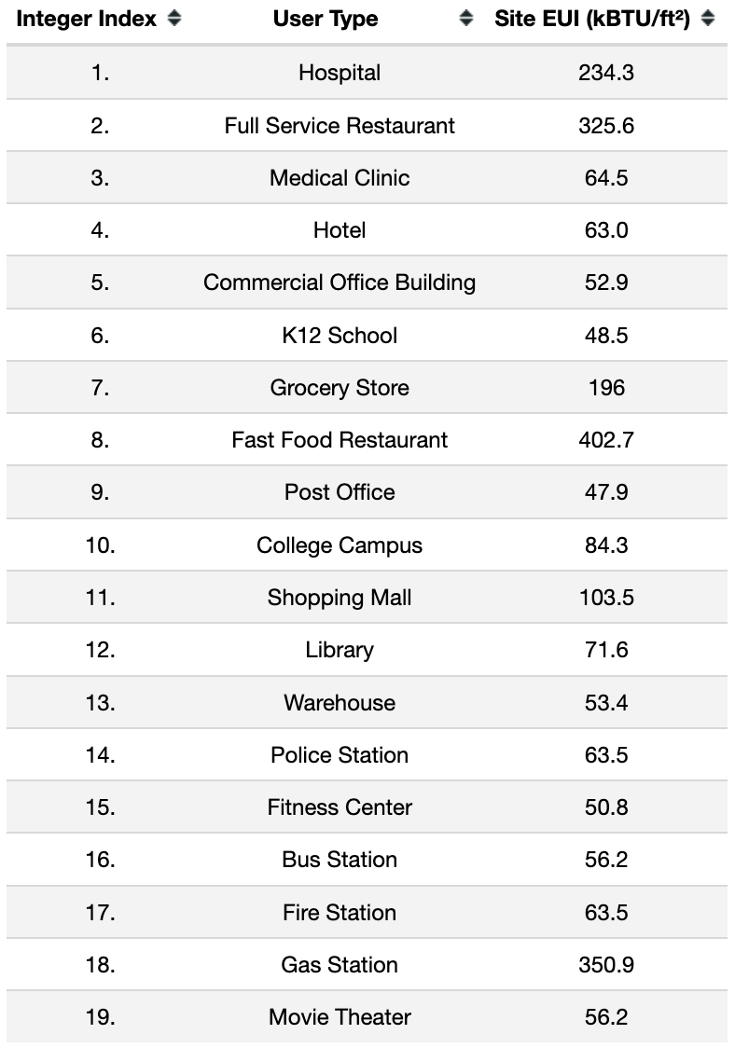
Figure 6. Table of 19 Possible User Types

STEP 5: Selecting your 10 User Types
- In “Section 2”, run the code cell and check the boxes that correspond to your 10 selected user types. After you have 10 blue checkmarks, click the green “Confirm Selection” button. The names of your chosen user types will then appear below the widget (see Figure 7).

Important Note:
- If you did not select exactly 10 user types, a message will appear prompting you to adjust your selections. You can modify your choices by adding and removing checkmarks.
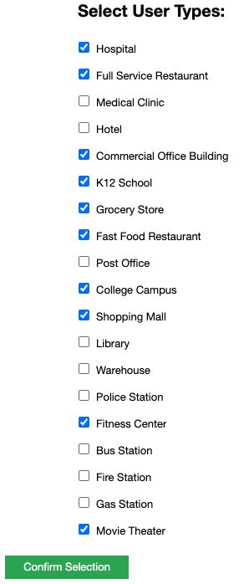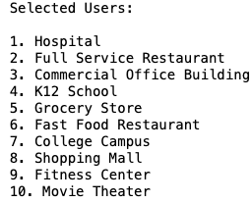
Figure 7. Example of User Type Selection

- After this widget cell, you MUST manually select then run the next cell (after confirming your selections). Unlike normal execution, the notebook does not automatically move to the next cell after this widget. If you click “Run” before selecting the next cell, the widget cell will re-run and you will need to re-enter your selections.

Run the last cell in “Section 2”, which saves your user type selections as a list for later use in the following sections (see Figure 8).
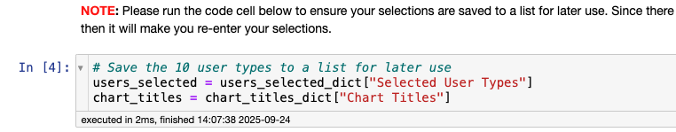Figure 8. Saving User Selections for Later Use

Important Note:
- You may change your user types after already selecting them, but you must remember to re-run all the cells below to ensure the correct plots, tables, and data are saved and displayed.

STEP 6: Plotting Energy Data for Each User Type
- Now that you have selected your 10 user types, run the two code cells in “Section 3” to display the daily energy consumption plots. The complete subplot will automatically be saved as “users_energy_plots.png” in the same folder as the notebook. If the plots were successfully saved, then a confirmation message will appear below the code cell.

Analyze the plots and note any similarities and differences in the energy consumption patterns across the 10 user types.

Important Note:
- If the subplot appears within a small scrollable window, click the left margin area of the output to “unscroll” the display. This will expand the plots so they can be viewed in full without scrolling. You should see an “unscroll” prompt appear when hovering to the left of the subplot (see Figure 9).
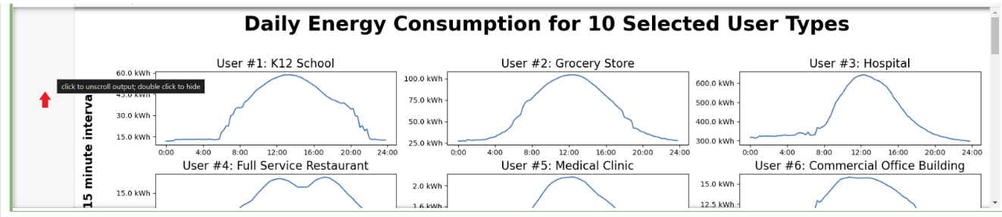Figure 9. How to “Unscroll” the Plots
- Please download the image file titled “users_energy_plots.png” that was generated in the same folder as this notebook.

To download the files generated by the code (such as the saved plots), return to the main Jupyter notebook file explorer tab. Check the box next to the file you want to download (one file at a time), then click “Download” at the top of the page (see Figure 9).
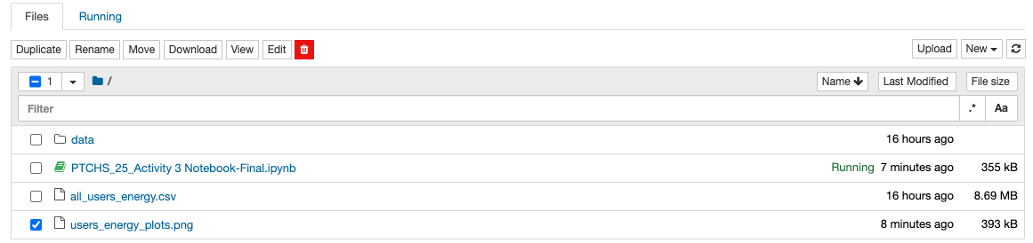Figure 10. How to Download Your Outputs from the Notebook

Paste a screenshot /image of your daily energy plots, from Step 6 above:

STEP 7: Analyzing Daily Trends in Energy Consumption
Now that you have produced the plots for your user types, consider the different daily patterns and make observations that can help you interpret the demand of different user types.
The plots use data measured in energy consumption (in kWh) for every 15-minute interval, meaning that there are 4 data points per hour, and 96 data points per day.

Energy Minima of Different User Types
Fill out the table by interpreting the graphs of daily energy consumption. What is the minimum value of energy consumption for each user? At what time does this occur? Why do you think this is the case?

User | Minimum Energy Consumption  (Time & kWh) | Why do you think it is lowest then?
1
2
3
4
5
6
7
8
9
10

Energy Maxima of Different User Types
Fill out the table by interpreting the graphs of daily energy consumption. What is the maximum value of energy consumption for each user? At what time does this occur? Why do you think this is the case?

User | Maximum Energy Consumption  (Time & kWh) | Why do you think it is highest then?
1
2
3
4
5
6
7
8
9
10

Why do you think daily energy consumption fluctuates for a given user type?
>

(STEPS 8–10) Pre-Work for Activity 4
In Activity 4, the total power distribution among your 10 user types will be used to create an Excel-based dashboard that you use to train your AI model to redistribute power during a partial outage. The total power among all users/buildings of each user type must be accounted for to generate the power distribution data that represents total demand on your grid.
The final part of the Notebook is used to create the power demand data, plots, and tables that you will be using in Activity 4.

STEP 8: Specifying the Number of Buildings for Each User Type
You may have more than one building for a given user type within your area.
- In “Section 4”, run the code cell and use the Python widget to specify the number of buildings for each user type. Adjust each slider to an integer value between 1 – 50, then click the green “Confirm Selection” button. The selected number of buildings for each of your 10 user types will be displayed below (see Figure 11).
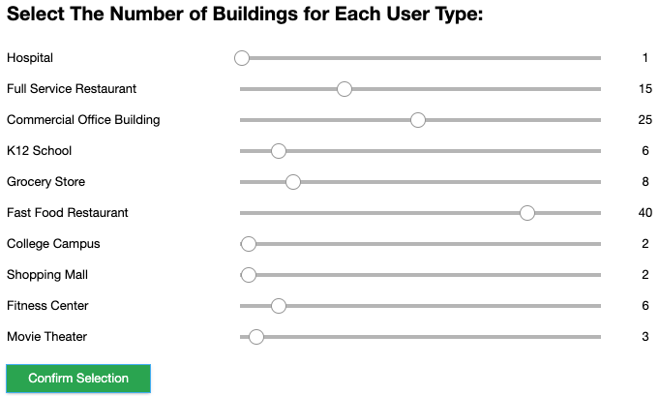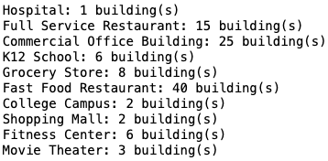
Figure 11. Example of Number of Buildings per User Type Selection

- Similar to the first widget cell, you MUST manually select and run the next cell (after confirming your selections). Unlike normal execution, the notebook does not automatically move to the next cell after this widget. If you click “Run” before selecting the next cell, the widget cell will re-run and you will need to re-enter your selections.

Run the last cell in “Section 4”, which saves your buildings selections per user type for later use in the following sections (see Figure 12).
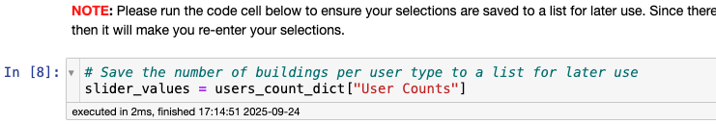Figure 12. Saving your Buildings per User Type Selections as a List for Later Use
Important Note:
- You may change your building numbers after selecting them, but you must remember to re-run all the cells below to ensure the correct plots, tables, and data are saved and displayed.

STEP 9: Generating Power Data
First, the Notebook will convert the energy data points from “Section 3” into power data points:
For each user: Power_{t1, t2, t3…} = Energy _{t1, t2, t3…} / (time interval); time interval = 15 minutes

Power_{t1, t2, t3…} = Energy _{t1, t2, t3…} / (15 minutes)

Then, the Notebook will multiply the power data for each user type by the number of buildings, which you use specified in STEP 8, to obtain the total power demand of each user type on your grid.

Additionally, the Notebook will compute the total power demand on your grid by summing the power data over time of all your user types.

The power demand data over a 24-hours period for each user type, along with the total grid power, will be saved as an excel file to your folder in NanoHUB.

- Run the code cell in “Section 5A”. If the power data was successfully saved, a message will appear below the code to confirm this (see Figure 13).
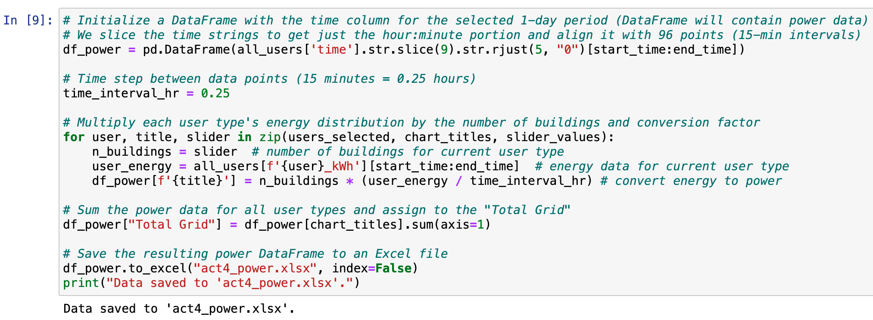Figure 13. Creating Power Demand Data for User Types

- Download the excel file titled “act4_power.xlsx” that was generated in your folder on NanoHUB. In Activity 4, you will copy the contents and paste them into the provided Activity 4 Excel Workbook to create the dashboard you will use to train your AI model. You can refer to the method you used to download the “users_energy_plots.png” file (see Figure 10).

STEP 10: Generating Power Plots
- Now that you have obtained your power data for each of your 10 user types and your total grid, run the two code cells in “Section 5B” to display the daily power demand plots. The entire subplot will also be saved as “users_power_plots.png” in the same folder as the notebook. If the power plots were successfully saved, then a message will appear below the code to let you know.

Analyze the difference in scale between the power required by the different user types and compare them to the power plot of the total grid.

- Download the image titled “users_power_plots.png” that was generated to use in Activity 4. You can refer to the method you used to download the “users_energy_plots.png” file (see Figure 10).

STEP 11: Generating Maximum Power Table
- To get a better feel for the relative power demand for your user types, you will produce a maximum power table, displaying each user type’s max power usage, the time at which it occurs, and its percentage (%) contribution to the entire grid’s maximum total power. This table will be used as a reference later, to confirm that your data was properly entered into the Activity 4 Excel workbook you will use as your dashboard.

Run the first code cell in “Section 5C” to display the max power table. If the table was successfully produced, then it will display below the code (see Figure 14).

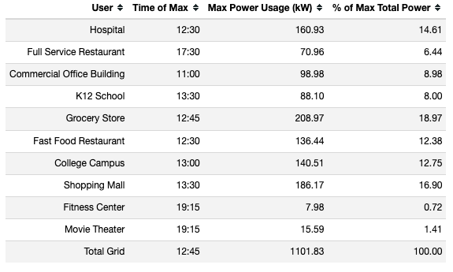
Figure 14. Example Maximum Power Table
Important Note about Maximum Power Table:
- Each user type reaches its maximum power at different times of the day. To compare them on the same relative scale, each user type’s maximum power was expressed as a fraction of the total grid’s maximum power (at the time the grid peaked). They were NOT normalized against the sum of all user types’ maximum powers. As a result, the percentages across all user types will NOT add up to 100%. The only way they would sum to 100% is if every user type happened to reach its peak at the exact same time of day.
- In practice, the total of these percentages can approach 100% when certain dominant user types are present (e.g., Hospitals), especially if multiple buildings of that type exist. A dominant user type is one that consumes significantly more power than the others. However, even a user type with relatively modest power demands (e.g., Grocery Stores) can become dominant in terms of its contribution to the grid if a large number of such buildings are connected to your grid (e.g., 30 stores).

- Now that you have displayed the maximum power table as a Pandas DataFrame, you can run the following code cell to transform the DataFrame into a table object using matplotlib. After it transforms, it will be displayed and saved as “max_power_table.png” in the same folder as the notebook. If the max power table was successfully saved, then a message will appear below the code to confirm this. The table object will look slightly different than the DataFrame, but it will have all the same numeric contents (see Figure 15).

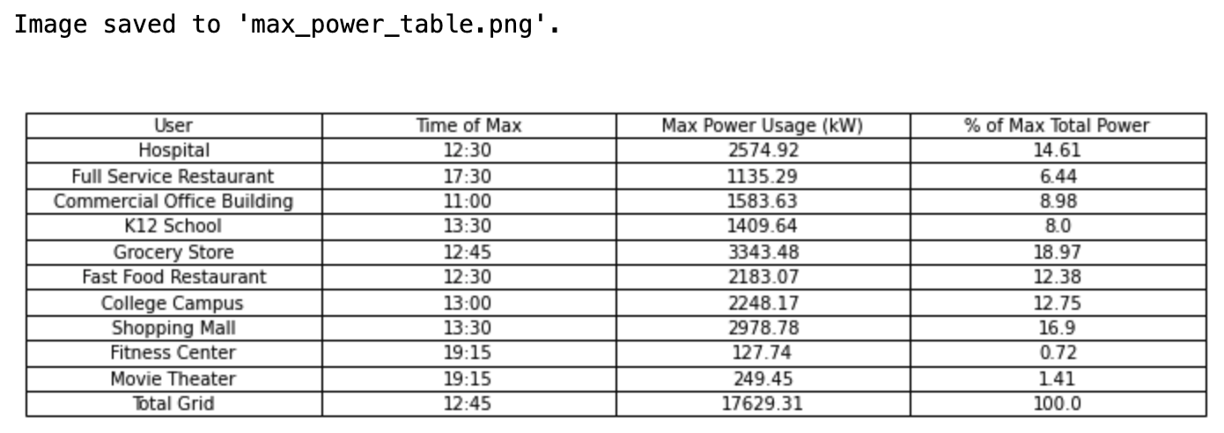Figure 15. Example of the Saved Maximum Power Table

- Download the image titled “max_power_table.png” that was generated to use as a reference in Activity 4. You can refer to the same method you used to download the “users_energy_plots.png” file (see Figure 10).

**Final Important Notes**
- If you have already run through the entire Jupyter notebook, AND THEN you decide to change either your 10 selected user types or the number of buildings per user type, you MUST re-run ALL the cells below the widget cell you made changes to.
- If you have already downloaded the data, tables, or plots to your personal device and THEN decide to make changes afterwards, you must not only re-run the cells below but you MUST re-download ALL the files that were saved below the widget cell you made changes to.

Resources: Power Cycle Overtime
Use and cite outside resources if needed.
U.S. Energy Use Intensity by Property Type – Energy Star
Average energy use per year for different user categories
Energystar.gov – Energy Star
Use the search bar to find reports on energy use throughout the U.S.
Energy Sustainability of Food Stores and Supermarkets – Energies Journal
Journal paper on energy use in grocery stores
Business Energy Advisor – Tennessee Valley Authority
Energy use information for many types of businesses

Submit After Completion
- Confirm that you have the following files downloaded to your device:
  - “users_energy_plots.png”
  - “act4_power.xlsx”
  - “users_power_plots.png”
  - “max_power_table.png”
- Ask your team’s mentor to check your work. Your team should make changes as needed.
- Save this document as a PDF with the title Activity_3_[Team Name].pdf and then have your Quality Engineer submit your PDF here: https://ufl.qualtrics.com/jfe/form/SV_eRiNCrlux5ALUKq

