Activity 2: Mapping your Community
Team Name:
Team Member Names:
Purpose:
- Teams will learn about the different stakeholders and power users in their community.
- Teams will create a map of an area in their community for which a smart power grid will be designed.
- Teams will identify 10 user types with 50 total users to represent top priorities for emergency service from their designed grid.
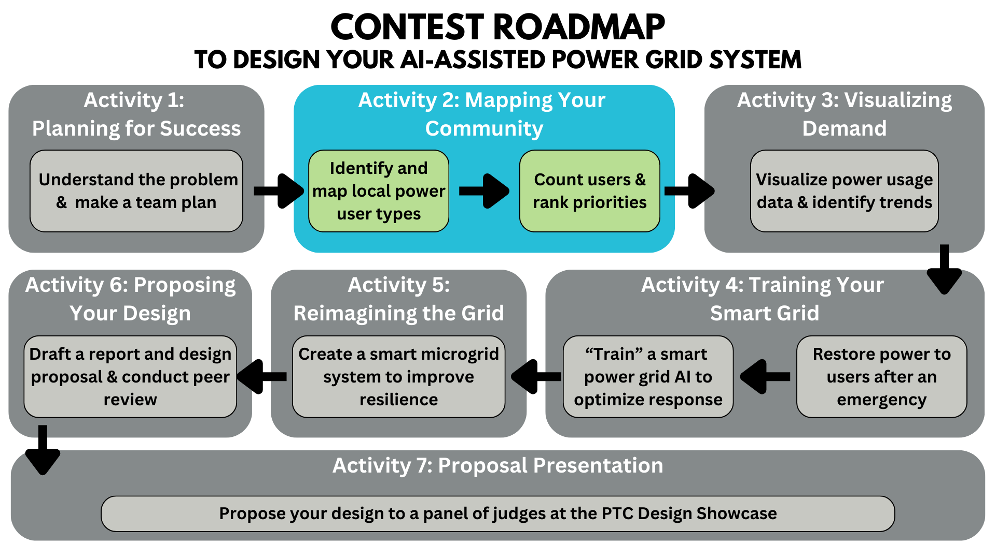
Activity Tutorial: https://www.youtube.com/watch?v=H14f0K5uqzE&ab_channel=EQuIPDGrant

Part 1: Mapping your Grid and Selecting Priority Users
In this activity, you will survey the area around your school and identify various individual energy users. You will classify the users into different types and decide on 10 types of users which you feel should be prioritized for power restoration following a natural disaster. You will then add at least 50 individual buildings included in these types to your map, representing users connected to your grid.

Links for the activity
Go to My Maps to create your map.
Use this KML Circle Generator to create a circular region that will represent the area service by your designed grid. You will need the latitude and longitude of your school’s location to do this. Remember, your circular region must encompass at least 50 buildings from among 10 different user types, so you may need to check out the layout of users in your community before you decide on radius.

Create your map and grid radius
- Go to My Maps (https://www.google.com/mymaps)
- In the top-left corner, click on Create A New Map.
- Click Untitled map in the top-left corner. Change your map title and description, then hit Save.
- To enable collaboration with your teammates and your mentor, click the Sharebutton. At the bottom-left corner of the pop-up, click Share on Drive. Change the General access from Restricted to Anyone with the link and change Viewer to Editor. Lastly, click Copy link and paste it below. This link will enable your team to work simultaneously, but you may have to hit refresh often to see the updates made by your teammates. Click Done.
Pasted Map Link:
- Find Base map in the bottom-left corner of the info square and select the Light Political option.
- Directly to the right of your new map title is a Search bar. Search for your school. A neon-green marker should drop onto your school, accompanied by a pop-up box with the details of your school.
- In the bottom-left corner of the pop-up box, click Add to map.
- To change the appearance of the marker, use the Stylebutton. Choose a color to represent the school user type.
- The latitude and longitude coordinates of your school should now be in the bottom-left corner of the pop-up box. Take note of these values or highlight them both, right click, and copy.
- Open a new browser window or tab. Go to the KML Circle Generator (https://www.scottmurray.me/kml/circle/index.php)
- Use the circle generator to generate a radius around your school in miles. Remember this radius must be large enough to encompass 10 different user types.
  - On the circle generator web page, for Center, type or paste in the latitude and longitude values you copied from your school on the map.
  - For Radius Value, enter the chosen radius of your circle in miles.
  - For Radius Units, click on the field and select Miles.
  - For Geometry, click on the field and select MultiGeometry.
  - Uncheck the box next to Include Center.
  - Click Generate, and the page will refresh.
- Scroll down and click Download under KML. A .kml file should download to your computer.
- In your Google MyMaps project, click the Layer optionsbutton next to Untitled layer. Go to Reimport and merge, followed by Add more items. Upload the .kml file that was downloaded to your computer.
- A black shaded circle should have been imported onto your map, representing your designated radius around the school. Under Untitled layer, click MultiGeometry. A pop-up should show up displaying the details of the shape on your map. Change the name of the circle by clicking the Edit button, and customize the color of the region for preference/readability by clicking the Stylebutton, both in the pop-up.

Add users to your map
- The list below summarizes some essential user types. With your team, choose 8 more user types found within the radius that are either essential or important for the grid design. Try to choose user types that are specific to your area and most reflective of your community. It may help to temporarily change the Base map to the Map style to easily see buildings within your radius. See this report for examples of user types. Record your additional users in the list below.
  - Schools/Shelters
  - Hospitals/ER
  - ____________________
  - ____________________
  - ____________________
  - ____________________
  - ____________________
  - ____________________
  - ____________________
  - ____________________
- In the info square, click Add layer  to add 9 new layers, one for each user type.
**Important: You can only create 10 layers total in a single map.
- To the right of Untitled layer, click the Layer options button and select Rename this layer to name it with the appropriate user type. Rename the first layer to “Schools/Shelters”.
- In each layer panel, click 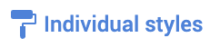, then select Sequence of numbers from the drop-down menu. This will number the markers on your map with a different sequence for each layer, so that you can see the number of users of each type.
- Click on one of the layer panels to select that layer. Use the techniques you learned in Step 6 and Step 7 to add users of the appropriate type to that layer. Choose a different color for each user type, so that all the users of a given type (in the same layer) have the same color.
- After you have added at least 50 total users, take a screenshot of your community map, focused on your circular region and the encompassed users, and paste the image in the next section.
**Important: Please zoom in on your map to display a good resolution of how your users are distributed.

Paste Screenshot of Map on this Page

Part 2: Prioritizing Power Users
Reflect on the priority with which the different user types in your community should have power restored in the event of an outage, based on your qualitative understanding of the services each user provides and their time sensitivity.
- Review the “How is power restoration prioritized following a storm or disaster?” section in the Activity 1 Background Reading. How would your team tailor the general restoration priorities to represent the important users in your community?
>

- Fill out the table below to summarize an initial power restoration plan for your community’s new smart grid. Create a numbered list prioritizing the user types you identified, with 1 being the most important. At this point, your team can choose to change which user types should be considered among your top 10. Mark any changes in your selected users on your map, by changing the name of the layer(s) and adding the new buildings. Count how many users are in each of your user types (e.g., 5 Restaurants, 1 Hospital).

User Rank | User Type | User Count
1.
2.
3.
4.
5.
6.
7.
8.
9.
10.

- Explain why your team decided on these priorities. Were the most essential users prioritized? Or were other factors considered? Write a paragraph using complete sentences.
>

- Explain any limitations you have in establishing priorities qualitatively. List initial questions you think should be answered in order for an AI model to help establish better priorities.
>

Submit After Completion
- Ask your team’s mentor to check your work. Your team should make changes as needed.
- Save this document as a PDF with the title Activity_2_[Team Name].pdf and then have your Quality Engineer submit your PDF here: https://ufl.qualtrics.com/jfe/form/SV_eRiNCrlux5ALUKq

