Activity 1: Planning for Success
Team Name:
Team Member Names:
Purpose:
- Provide an overview and timeline of the contest that explains the contest goals, procedures, deliverables of contest activities (1–7).
- Complete background reading to learn about the current state of “the Grid”, the basics of smart technologies and microgrid design, and how smart power grids improve resilience against emergency outages.
- Assign team roles to team members to divide contest responsibilities.
- Develop a team work plan and calendar to schedule time each week to work together and communicate with your team’s mentor.
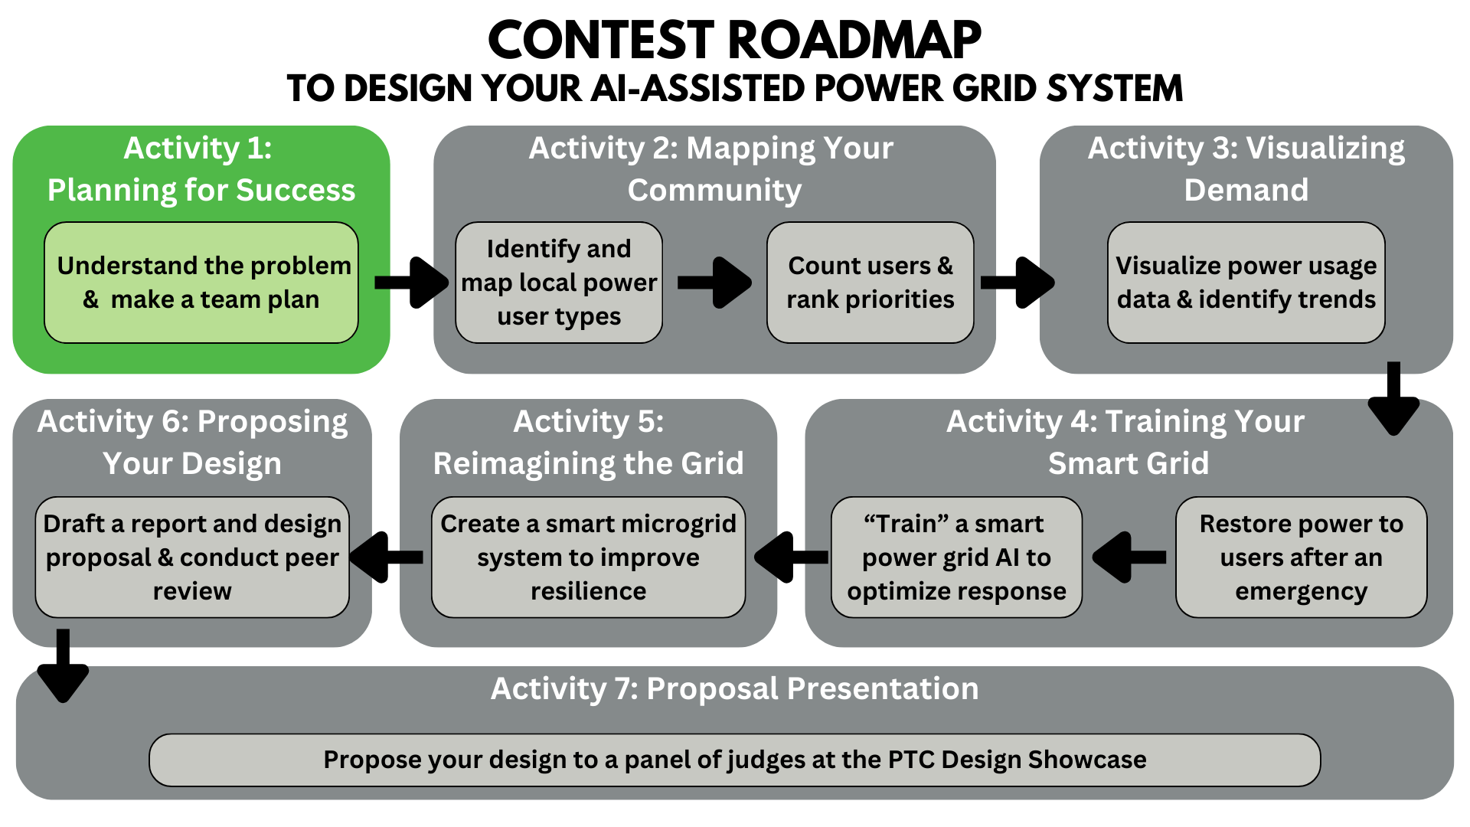
Activity Tutorial: https://youtu.be/FL17EgQafGA?si=afjJ3rk03eskRd4d

Table of Contents
Part 1: Contest Overview 3
Part 2: Background Reading 4
Key Terms 4
Energy and Power Generation 5
Energy vs. Power 6
What is “the Grid”? 6
What is a smart power grid? How is it different from a traditional power grid? 7
Advantages of “smart” micro grids over the traditional power grid: 8
How can smart grids help during an emergency or natural disaster? 8
How is power restoration prioritized following a storm or disaster? 9
Current ways power outages are mitigated 10
Relevant Research Papers 11
References 12
The “Grid” 12
Smart Grids 12
Smart Grids and Natural Disasters 12
Part 3: Team Name and Assigning Team Roles 13
Part 4: Activity Deliverables Checklist 14
Part 5: Team Work Plan and Calendar 15
Contest Activity Timeline 15
Activity Completion Roadmap 15
Team Workplan 16
Team Work Calendar 17
After Completion: 19

Part 1: Contest Overview
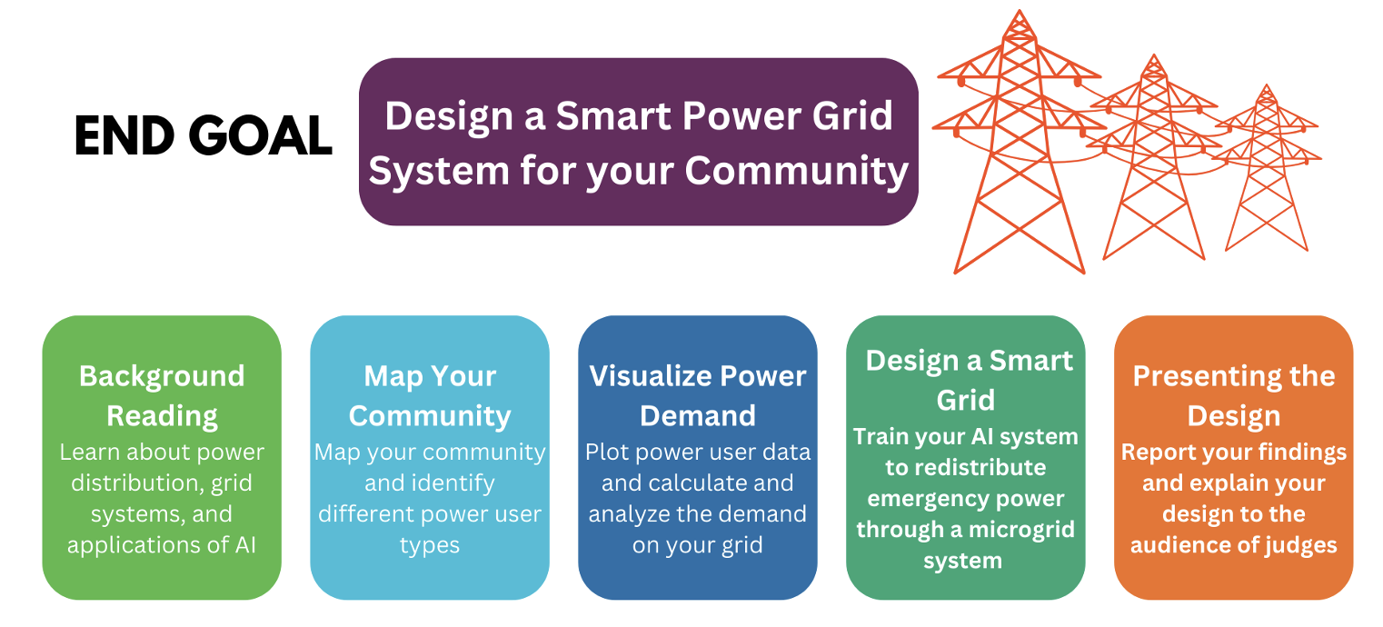
In this design contest, your team will work together as a group of engineers to design a smart microgrid system that manages emergency power distribution among different users in your community.
In Activity 1, you will read about grid systems and how they operate. Your team will create a plan to complete activity deliverables and reach your goal of designing a smart microgrid system.
In Activity 2, your team will map the community around your school to identify 10 different types of power users and how they are positioned throughout your theoretical grid. Your team will develop initial ideas about how different users could be prioritized for power restoration in the event of an emergency.
In Activity 3, your team will use a Python-programmed Jupyter Notebook to visualize and select different energy data sets to represent your different user types. You will account for how many users of each type are on your grid to determine the overall power demand distribution among your grid.
In Activity 4, your team will use an Excel workbook to create a visual dashboard of your grid’s power demand distribution, then follow a manual procedure to decide how a limited amount of emergency power will be restored among different users. You will create data “snapshots” that would be used to train your AI system to create a more optimal procedure for restoring power over the first 24 hours following the emergency outage.
In Activity 5, your team will reimagine your total grid of users into a system of microgrids to which you assign different restoration priorities. You are tasked with proposing a method for your AI system to learn from the training snapshots and control microgrid operations.
In Activity 6, your team will report how you analyzed data to inform your design process. You will draft a proposal for your designed microgrid system. You will practice presenting your design to your peers.
In Activity 7, your team will formally propose your microgrid system design to judges from Duke Energy in the Powering the Community Design Showcase.
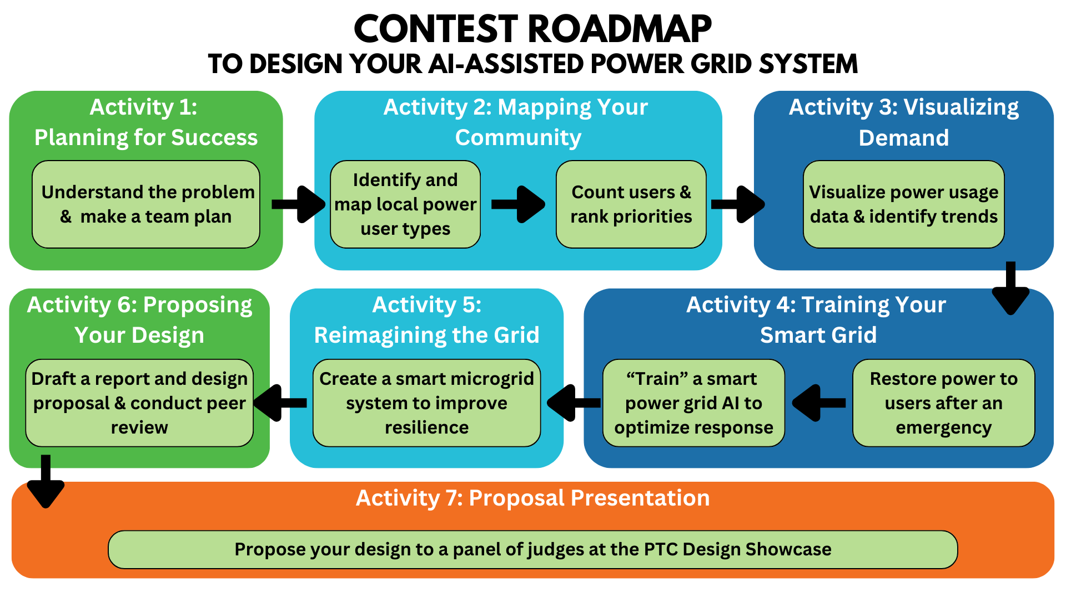

Part 2: Background Reading
Instructions: Read the background information to gather context before you begin your design process.

Key Terms
Energy – the ability of a system to do work
Power – the rate at which energy is transferred/work is performed
Power plants – industrial electricity generators, traditionally from coal or natural gas
Loads – electricity consumers such as homes and businesses
The Grid – the collection of infrastructure that facilitates generation and distribution of electricity
Transmission lines – conductive cables that can transport energy throughout a state
Distribution lines – conductive cables that transport energy throughout neighborhoods
Transformers – increases (step-up) or decreases (step-down) the amount of power that is transmitted
Substations – areas that contain transformers to control power before it is distributed to the loads

Energy and Power Generation
Gas, coal, solar energy, wind, and even the tides are examples of energy sources.
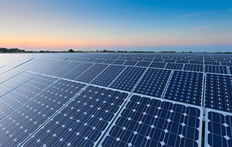
Copyright: https://www.duke-energy.com/energy-education/how-energy-works
Energy that is stored in different sources, such as fuels, can be accessed to perform work when the stored energy is converted into different forms. Thermal power plants apply engineering design principles to harness work by converting chemical potential energy stored in fossil fuels into thermal, kinetic, mechanical, and finally electrical energy that is distributed to electricity consumers, called loads. Most of the electricity in the United States is generated in thermal power plants that use fossil fuels, such as coal, oil, and natural gas, which are valued for their high energy density. Energy density refers to the amount of energy that can be accessed from conversion of a given mass or volume of fuel.
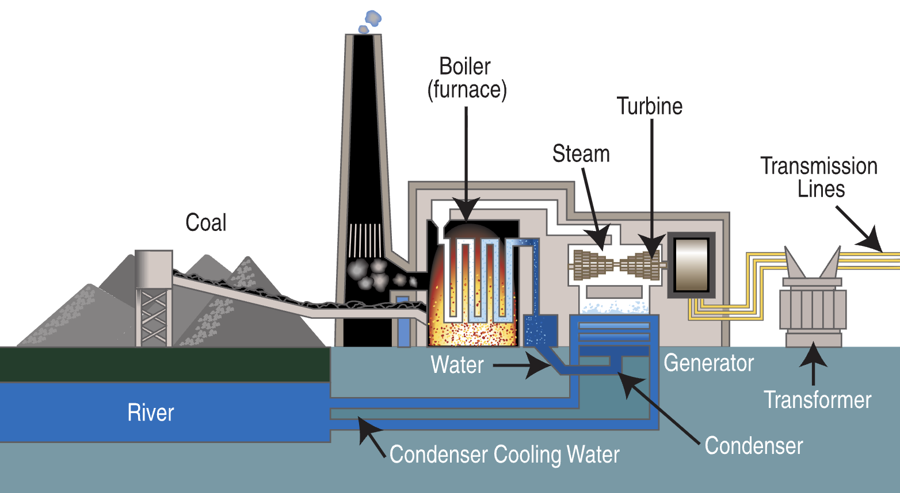
Copyright: https://upload.wikimedia.org/wikipedia/commons/4/4a/Coal_fired_power_plant_diagram.svg
Power refers to the rate at which energy is converted from one form to another, or the rate at which it is transferred from one system to another, in order to do work. Power is calculated by measuring a change in energy and dividing this by the time period over which the measurement was taken. Thinking in terms of distance, energy is comparable to miles traveled, while power is comparable to speed in miles per hour [20]. In the case of electricity produced by power plants, power is used to describe the rate at which electricity can be delivered to consumers.

Energy vs. Power
Energy is typically quantified using British thermal units (BTU), watt-hours (Wh), and joules (J). In the United States, electricity bills are calculated by pricing the total kilowatt-hours (kWh) used by a consumer over the course of a month. When looking at energy bills for different buildings, energy consumption values can only be directly compared if the measurements were taken over the same amount of time, e.g, total kWh used over one year [20]. Consumers are charged based on energy (kWh) measurements because energy values represent how much electricity the consumer used, which also reflects how much of various resources were consumed to generate the electricity.
Power is typically measured in watts (W), and 1 watt is equal to 1 Joule per second (J/s). Power can be thought of as an immediate “state” of operation that can be compared among different users without prescribing a specific time frame. It reflects how readily energy can be distributed from generation sites. The power of a power plant is dependent upon both its capacity to generate electricity and the efficiency with which the electricity travels through different parts of “the Grid”.

What is “the Grid”?
“The Grid” refers to the system of physically interconnected infrastructure that facilitates power distribution from generation sites to users, called loads, in the form of electricity. Once it is generated by a power plant, electricity travels through big cables into transformers that “step-up” the voltage for high-speed transmission over long distances, sending electricity through transmission lines and into special stopping points called substations. Substations “step-down” the voltage for more localized distribution to users via smaller cables called distribution lines. A network of substations helps control how much electrical power from power plants is divided among different user types through various types of power lines [1, 2].
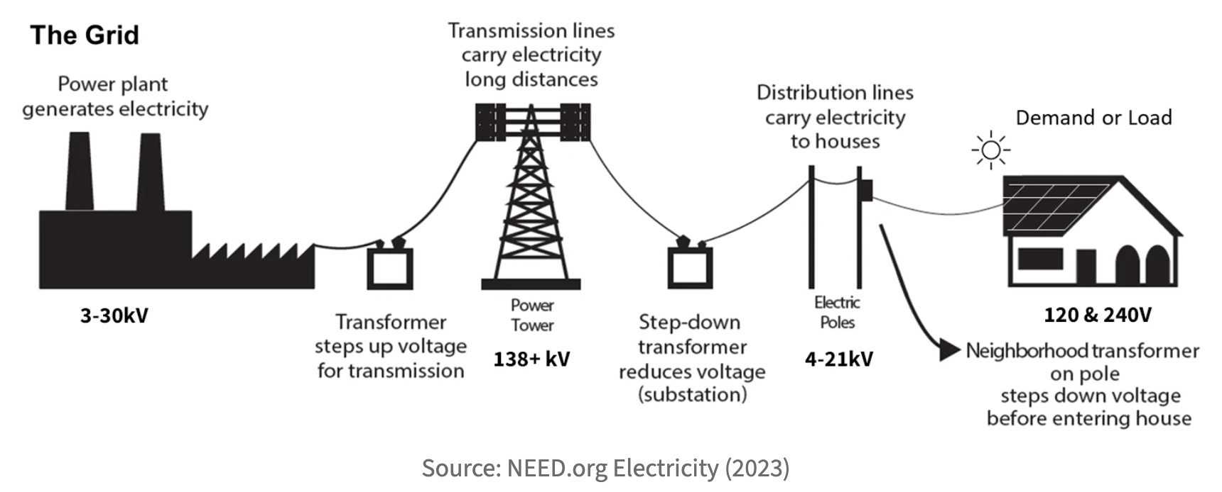
Copyright: https://understand-energy.stanford.edu/energy-currencies/electricity-grid

“The Grid” refers, more specifically, to the traditional electric grid, built in the 1890s, that is still used today. Since then, parts of the grid have been expanded and updated, but the underlying design has remained the same due to intensive costs associated with constructing and integrating alternative infrastructure. In the traditional grid, electricity moves in one direction, from power plants to loads, through the network of transmission and distribution lines, transformers, and substations [3, 4].
In the traditional grid system, power demands are estimated, and utility companies do not monitor energy flow once it leaves the plant [8]. Power company employees must physically visit loads every month to manually read usage meters. As electricity demand continues to rise, this system becomes increasingly time intensive, and a need arises to streamline power monitoring through the incorporation of more advanced technologies. This is where the smart power grid comes in!
See the links below for more information about power grids:
A. https://science.howstuffworks.com/environmental/energy/power5.htm
B. https://www.science.smith.edu/~jcardell/Courses/EGR220/ElecPwr_HSW.html
C. https://justenergy.com/blog/power-grid-what-is-it-and-how-does-it-work/

What is a smart power grid? How is it different from a traditional power grid?
A smart power grid incorporates network-based technologies, including remote usage metering, sensor-control systems, and computer analysis of power distribution data, to implement adaptive automated systems that can more proactively assess and anticipate immediate and future energy needs. Smart grid systems center on establishing real-time, two-way communication throughout the network so that power distribution can be more finely controlled to align with actual monitored demand [3, 4]. In addition to advancements in communication technologies, smart grids center on more advanced infrastructure design, such as the distribution of loads into smaller modules, called microgrids.
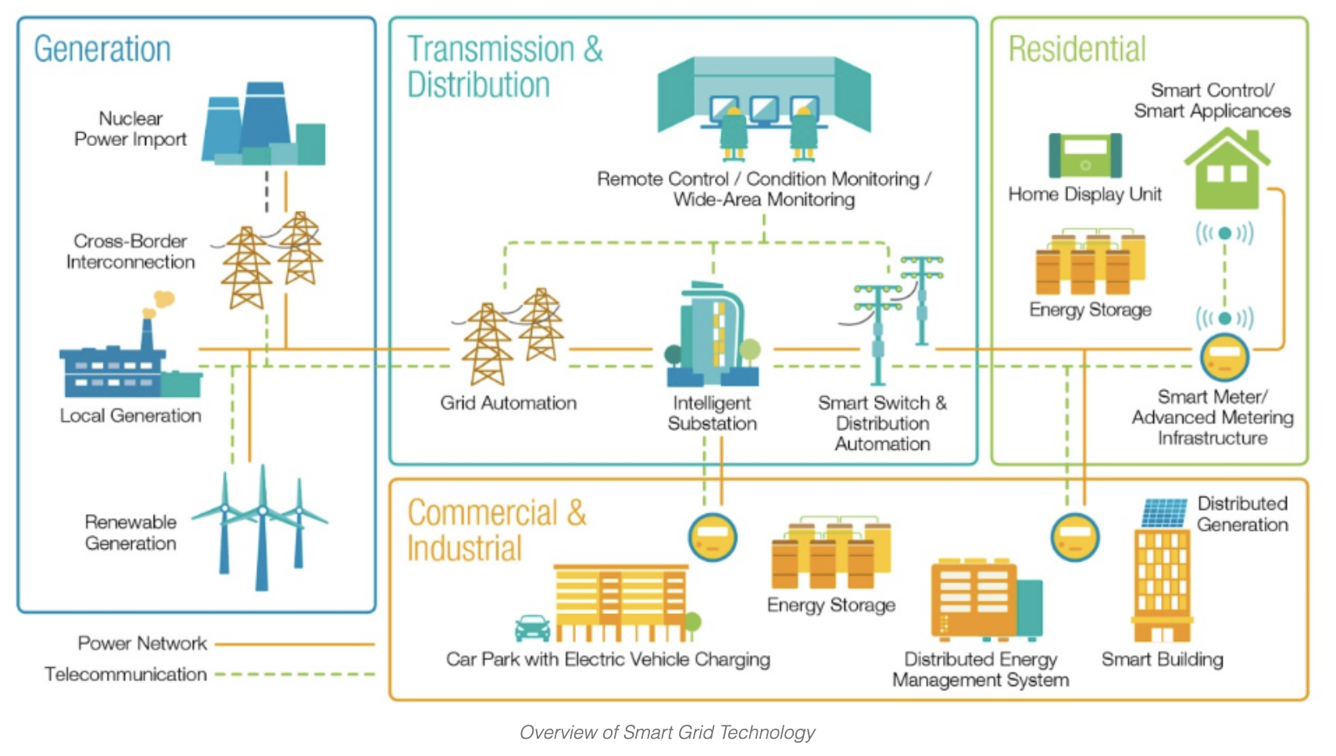
Copyright: https://www.elprocus.com/wp-content/uploads/2017/02/grid-overview.png

Advantages of “smart” micro grids over the traditional power grid:
- Better management and control: Traditionally, utility companies estimate how much power is needed to supply a home, and an outage isn’t discovered until someone calls to report it. Smart grid technologies allow both consumers and producers to monitor and control usage in real-time, remotely. Thus, loads receive closer to the exact amount of power they need, and outages are reported immediately [3–6].
- Less centralized + more distributed = more resilient: Traditional grid designs center entire regions of consumers around a few main power plants, and an outage at the plant can impact the majority of serviced loads. In contrast, microgrid arrays tailor distribution from smaller sources to serve localities nearer the generation site. An outage that affects a single plant impacts a smaller proportion of users, improving reliability of the overall system [3, 5].
- Integration of advanced energy production and diversified generation: Infrastructure to support electric vehicles and other ongoing efforts in renewable energy are easier to integrate into modules of a microgrid system. Shorter distances between generation and consumption sites enables a main power supply to be supplemented by consumer-owned generators and renewable energy sources. Buildings with localized generation technology, such as solar cells, can input excess energy back into the grid for distribution—enabling a two-way system [3, 4]. In an ideal situation, excess energy produced by one microgrid can function as reserve power when other modules of the system experience an outage.
- Lower energy cost: All the above advantages lower the cost of energy by simplifying utility management, reducing downtime from outages, and improving efficiency. Moving toward sustainable energy sources also reduces negative impacts of energy production on the environment [6, 7, 9, 10].

How can smart grids help during an emergency or natural disaster?
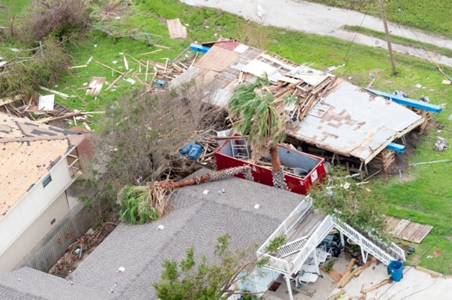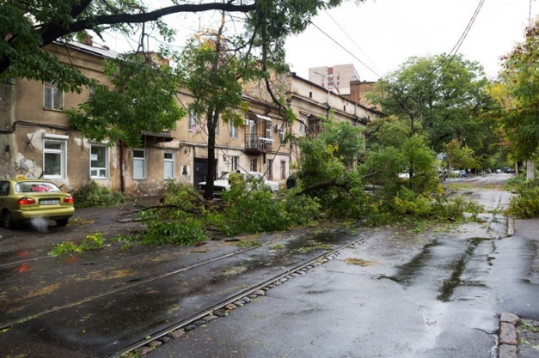
©asphotos/123RF.COM ©elarina/123RF.COM

During a natural disaster, such as a hurricane or tornado, strong winds and accompanying debris may easily knock down distribution lines. When infrastructure is significantly flooded, the water must recede before substations can be accessed for repairs [6–10]. As a result, hospitals and other critical, time-sensitive resources can be left without power until long after the disaster ends. During catastrophic events, many schools become active emergency shelters for those that need to evacuate an area in favor of a safer place to stay [13]. Advancements in resilient grid technology are vital to efficiently restoring power to loads that are crucial for supporting public safety in the community.
The grid isn’t vulnerable to only disasters. Climate change has significantly increased both the frequency and intensity of heatwaves and winter storms [10–12]. These phenomena have the potential to melt distribution lines or freeze entire power plants [12].
In the traditional grid design, outages are not made known to the utility company until someone reports the problem. A team of workers must be sent out to diagnose the issue before equipment necessary for repairs can be brought to the site. With smart grid technology, power distribution failures can be immediately detected and remotely diagnosed. If excess power is available in other parts of the grid, it may be rerouted to the affected area proactively, and the outcome can be shifted from a sustained outage to a momentary flicker in electricity [5].
Of course, automation and remote controls alone cannot prevent large-scale blackouts during a disaster. Structural reinforcements, or “grid hardening”, are required to physically bolster the grid and mitigate vulnerability against the damaging forces of a natural disaster [9, 10, 12]. Grid hardening may include replacing wooden with concrete distribution line poles that can withstand high winds, more extensive infrastructure in flood zones, or moving power lines underground. What smart grid technologies do readily mitigate is the time elapsed until power is restored to critical consumers. Over time, the sensing ability of smart grids can also be used to mine data from outages to improve recommendations for infrastructural changes. With the help of statistical modeling and AI, utility companies can use this data to better prepare for upcoming disasters and make decisions on which areas are most in need of hardening [7, 9, 11, 12].
Smart Grid
Traditional Grid

How is power restoration prioritized following a storm or disaster?
Planning for power restoration begins long before disaster strikes. Electric companies run company-wide drills and make plans with the local government to prepare for different events [15, 16].
Generally, the first step following an outage is for power distributors to send out teams to assess the damage and ensure no power flows through downed lines, which can be deadly. If a power plant itself is damaged, its repair is made top priority, as the plant provides power to the rest of the downstream grid system. The next priority is repairing transmission lines and substations, which control how power is distributed from the plant to entire regions of consumers. Water and wastewater plants are also restored with high priority, to ensure that emergency responders have a clean water supply. Once utility functions of the system are restored, distribution to loads with emergency functions, including hospitals, police and fire stations, and communication systems, are chief priority. After these essential needs are met, individual distribution lines are fixed based on how quickly they can get power to the largest number of people. This includes lines that power whole neighborhoods, industries, or large businesses, and individual homes are typically the last priority in power restoration [15, 16]. Generally, the closer your region is to a transmission line, and the closer you are to a distribution line, the faster you will get power restored.

Current ways power outages are mitigated
A blackout is a complete interruption of power in a specified area. Brownouts, on the other hand, are reductions in voltage that last from minutes to hours. During a typical brownout, transmission voltages are decreased by 10–25%, lowering the rate of power distribution, and most electronics are not affected by this voltage change.
Brownouts can be unintentional, due to infrastructural damage, or they can be intentionally induced by utility companies. In emergencies such as a natural disaster, controlled brownouts or rolling blackouts may be induced to reduce the total power load and prevent a more severe, longer-term blackout. Planned outages may also be implemented by utility companies for maintenance or to reduce operational stress on the grid system. However, most largescale blackouts are caused by natural disasters or catastrophic events [14].
Since the late 1990s, there have been increased efforts to update the Grid at more localized scales through the implementation of microgrids. Because they are modular, microgrids can be tailored to different community layouts and environments, allowing for designs that access energy resources supplementing power received from primary plants on the grid. For example, communities that receive large amounts of sunlight can take advantage of small-scale solar infrastructure to store backup power that protects the microgrid during a brownout or rolling blackout. With advancements in the efficiency with which microgrids interface with the main grid, microgrids can even sell excess power back to the main grid, reducing the likelihood or duration of outages that occur throughout other parts of the grid when it is over stressed.

Relevant Research Papers
Use the research papers below to learn more about the information discussed in this activity. These can also be used as references for your final proposal presentation.
- A Comprehensive Review on Smart Grids: Challenges and Opportunities https://www.ncbi.nlm.nih.gov/pmc/articles/PMC8587637/
  - This paper provides an overview of smart grids. It discusses the challenges and opportunities that smart grids bring to electrical power grids. This paper analyzes different aspects of smart grids like its technological advancements, challenges in implementation, and opportunities for enhancing energy management. Use this paper to get a better understanding of smart grids and how they are evolving.
- A Comprehensive Review of Recent Advances in Smart Grids: A Sustainable Future with Renewable Energy Resources
https://www.researchgate.net/publication/347221538_A_Comprehensive_Review_of_Recent_Advances_in_Smart_Grids_A_Sustainable_Future_with_Renewable_Energy_Resources
  - This paper gives an in-depth overview of developments in smart grids and the integration of renewable energy resources into smart grids. The goal of this paper is to understand how smart grids can support renewable energy integration in the future.
- Recent Advancments in Smart Grid Technology: Future Prospect in the Electrical Power Network https://www.sciencedirect.com/science/article/pii/S2090447920301064
  - This paper explains smart grids and their implications for the electrical power network while highlighting the challenges in both production and distribution. Smart grids provide a solution to these challenges by enhancing the efficiency, reliability and sustainability of the electrical distribution system.
- Overview of Smart Grid Implementation: Framework, Impact, Performance, and Challenges https://www.sciencedirect.com/science/article/abs/pii/S2352152X22000950
  - This paper provides a survey of smart grid frameworks and their impact from 2015 to 2021 due to the increasing demand for electricity. Furthermore, the paper explores the framework of smart grids by examining its social, economic, and environmental impacts. It also provides information on how transforming traditional grids into smart grids works.

References

The “Grid”
[1] “Duke Energy Corporation,” Duke Energy, 2020. https://www.duke-energy.com/energy-education/how-energy-works
[2] “Duke Energy Corporation,” Duke Energy, 2020. https://www.duke-energy.com/energy-education/how-energy-works/delivering-electricity

Smart Grids
[3] Smart Grid: The smart grid. Smart Grid: The Smart Grid | SmartGrid.gov. (2019, December 16). https://smartgrid.gov/the_smart_grid/smart_grid.html
[4] Michaelson, H. (2021, February 24). Smart grids: Updating the traditional grid. Medium. https://medium.com/sjei/smart-grids-updating-the-traditional-grid-7979bed47761#:~:text=The%20traditional%20power%20grid%20moves,of%20energy%20into%20the%20grid.
[5] How the smart grid keeps your power on. What is Smart Energy? (n.d.). https://whatissmartenergy.org/how-the-smart-grid-keeps-your-power-on
[6] Smart Grid and power quality. What is Smart Energy? (n.d.-b). https://whatissmartenergy.org/smart-grid-and-power-quality
[7] Iea. (n.d.). Smart grids. IEA. https://www.iea.org/energy-system/electricity/smart-grids

Smart Grids and Natural Disasters
[8] Public Broadcasting Service. (n.d.). Hurricane Sandy and the limits of the smart grid | inside nova. PBS. https://www.pbs.org/wgbh/nova/insidenova/2012/11/hurricane-sandy-and-the-limits-of-the-smart-grid.html
[9] Muhammad Waseem. (2020, November 3). Electricity Grid Resilience amid various natural disasters: Challenges and solutions. The Electricity Journal. https://www.sciencedirect.com/science/article/pii/S1040619020301561
[10] WP Company. (2021, October 24). Longer, more frequent outages afflict the U.S. power grid as states fail to prepare for climate change. The Washington Post. https://www.washingtonpost.com/business/2021/10/24/climate-change-power-outages/
[11] Sanstad, A. H., Authors, Sanstad, A. H., Larsen, P. H., & Eto, J. H. (n.d.). Case studies of the economic impacts of power interruptions and damage to electricity system infrastructure from extreme events. Case Studies of the Economic Impacts of Power Interruptions and Damage to Electricity System Infrastructure from Extreme Events | Electricity Markets and Policy Group. https://emp.lbl.gov/publications/case-studies-economic-impacts-power
[12] Dhanesha, N. (2021, December 2). The futuristic plan to fix America’s Power Grid. Vox. https://www.vox.com/recode/22812748/storm-hurricane-heatwave-climate-infrastructure-smart-grid-ai
[13] Home. FloridaDisaster.org. (n.d.). https://www.floridadisaster.org/
[14] Understanding brownouts and blackouts: Causes, effects, and solutions. California Commercial Generator Sales, Rental, Maintenance & Service. (2023, March 29). https://www.gotpower.com/brownouts-and-blackouts/
[15] Understanding the electric power industry’s response and restoration ... (n.d.). https://www.eei.org/-/media/Project/EEI/Documents/Issues-and-Policy/Reliability-and-Emergency-Response/MA_101.pdf?la=en&hash=ED8AAD4C4C9B2EFA7B6A0A7663A15A6C03C61794
[16] ig.uana.16. (2021, April 15). How the Electric Company restores power after a Storm. Pro Tool Reviews. https://www.protoolreviews.com/how-power-restored-after-storm-order/

CONTINUE ON NEXT PAGE

Part 3: Team Name and Assigning Team Roles
Instructions: Decide together on a team name. Provide your team name at the top of this document and every future activity document that you submit.
Each of your team members is an equal participant in the design process throughout all activities. Everyone has a voice and will share ideas to complete the contest objectives. Below is a table with four roles and their descriptions.
Instructions: Read the descriptions, and, as a group, decide who will take on what role. These roles each have key responsibilities that are important to your project’s success. Write each team member’s name in the table next to their assigned role.
Role Name | Key Responsibilities | Team Member Name
Project Manager | - Manages correct and on-time completion of Activity 1  - Keeps team on track with their team workplan  - Ensures all activities are completed by all team members  - Assigns tasks to themself and team members  - Leads communications with team’s mentor
Quality Engineer | - Manages correct and on-time completion of Activity 2  - Reviews tables, graphs, and schematics for proper formatting  - Edits activity submissions for proper grammar and formatting  - Reviews and submits all activities  - Reviews and edits final report
Energy Analyst | - Manages correct and on-time completion of Activities 3 and 4  - Leads team to quantify power consumption of different users  - Leads team discussions about data analysis  - Leads team discussions about AI design
Design Architect | - Manages correct and on-time completion of Activity 5  - Leads discussion on prioritization of different power users  - Leads discussion on microgrid design  - Leads team’s creation of final grid proposal

Part 4: Activity Deliverables Checklist
The checklist below outlines the various deliverables your team will submit within the contest activities. You can click in a box to check it off!
Activity Name | Deliverables Checklist
Activity 1: Planning for Success | ☐ Review Contest Overview and Timeline  ☐ Complete Background Reading  ☐ Assign Team Roles  ☐ Review Activity Deliverables Checklist  ☐ Communicate with mentor to set weekly meeting  ☐ Develop Team Workplan and Calendar  ☐ Activity 1 PDF submitted
Activity 2: Mapping Your Community | ☐ Use Google MyMaps to create a grid radius around your school  ☐ Select 10 critical user types and add at least 50 users to your map  ☐ Paste screenshot of your power grid map in the Activity 2 document  ☐ Complete discuss to establish a baseline for “Prioritizing Power Users”  ☐ Activity 2 PDF submitted
Activity 3: Visualizing Demand | ☐ Access and Launch Jupyter Notebook through Nanohub  ☐ Select 10 data sets to represent your 10 user types  ☐ Analyze daily energy consumption profiles  ☐ Account for number of each user and generate their total power plots  ☐ Complete notebook procedures to export power data sets  ☐ Activity 3 PDF submitted
Activity 4: Training Your Smart Grid | ☐ Read “Setting the Scene” and “What is ‘Artificial Intelligence?’”  ☐ Transfer your data to excel Workbook  ☐ “Get to Know” the Dashboards and tables in the Excel workbook  ☐ Redistribute reduced emergency power to generate training “snapshots”  ☐ Interpret new plots generated in Outage Dashboard  ☐ Complete tables and answer questions in Activity 4 document.  ☐ Activity 4 PDF submitted
Activity 5: Reimagining the Grid | ☐ Calculate average power usage of individual buildings on your grid.  ☐ Assign all users to at least three microgrids.  ☐ Display microgrids on your map.  ☐ Explain AI procedure/algorithm for assigning/operating microgrids.
Activity 6A: Design Proposal Draft, Executive Summary Draft  Activity 6B: Feedback | ☐ Executive Summary draft PDF submitted  ☐ Design Presentation PowerPoint draft PDF submitted  ☐ Review and discuss other teams’ proposal PDFs.  ☐ Complete tables to provide feedback  ☐ Activity 6B PDF submitted
Activity 7: Design Showcase | ☐ Submit finalized Design Proposal PowerPoint + Executive Summary PDF  ☐ Present to a panel of judges at UF  ☐ Network with UF Engineering Students  ☐ Take an Engineering Campus Tour

Part 5: Team Work Plan and Calendar

Contest Activity Timeline
Below is an image of the Contest Activity Timeline. This timeline shows important dates of the contest that you should keep in mind to stay on track as you complete each of the contest Activities.
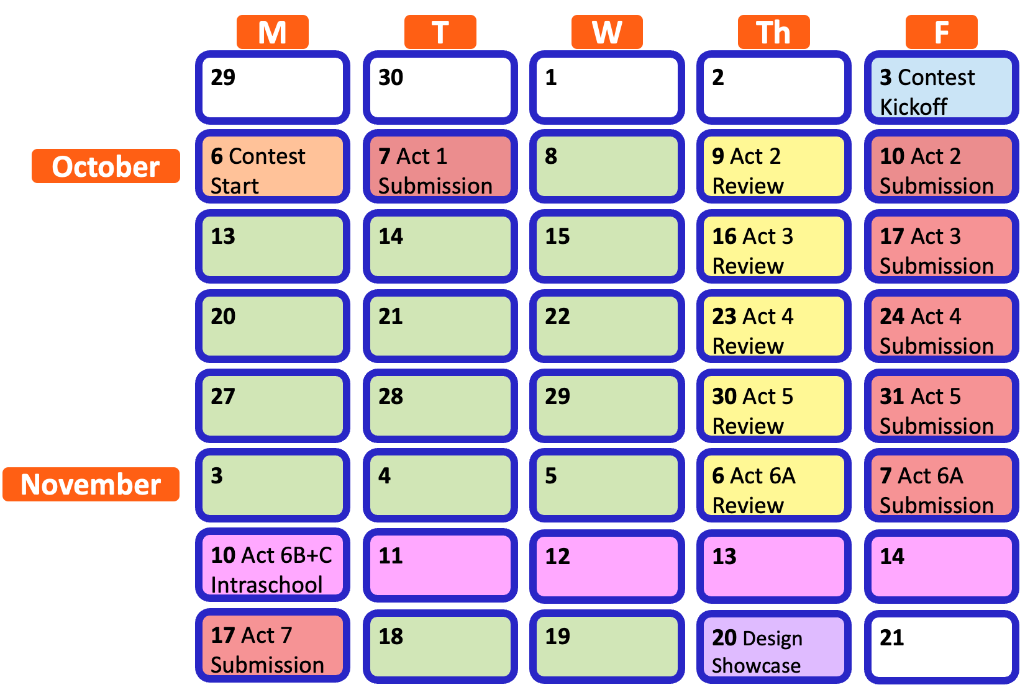

Activity Completion Roadmap
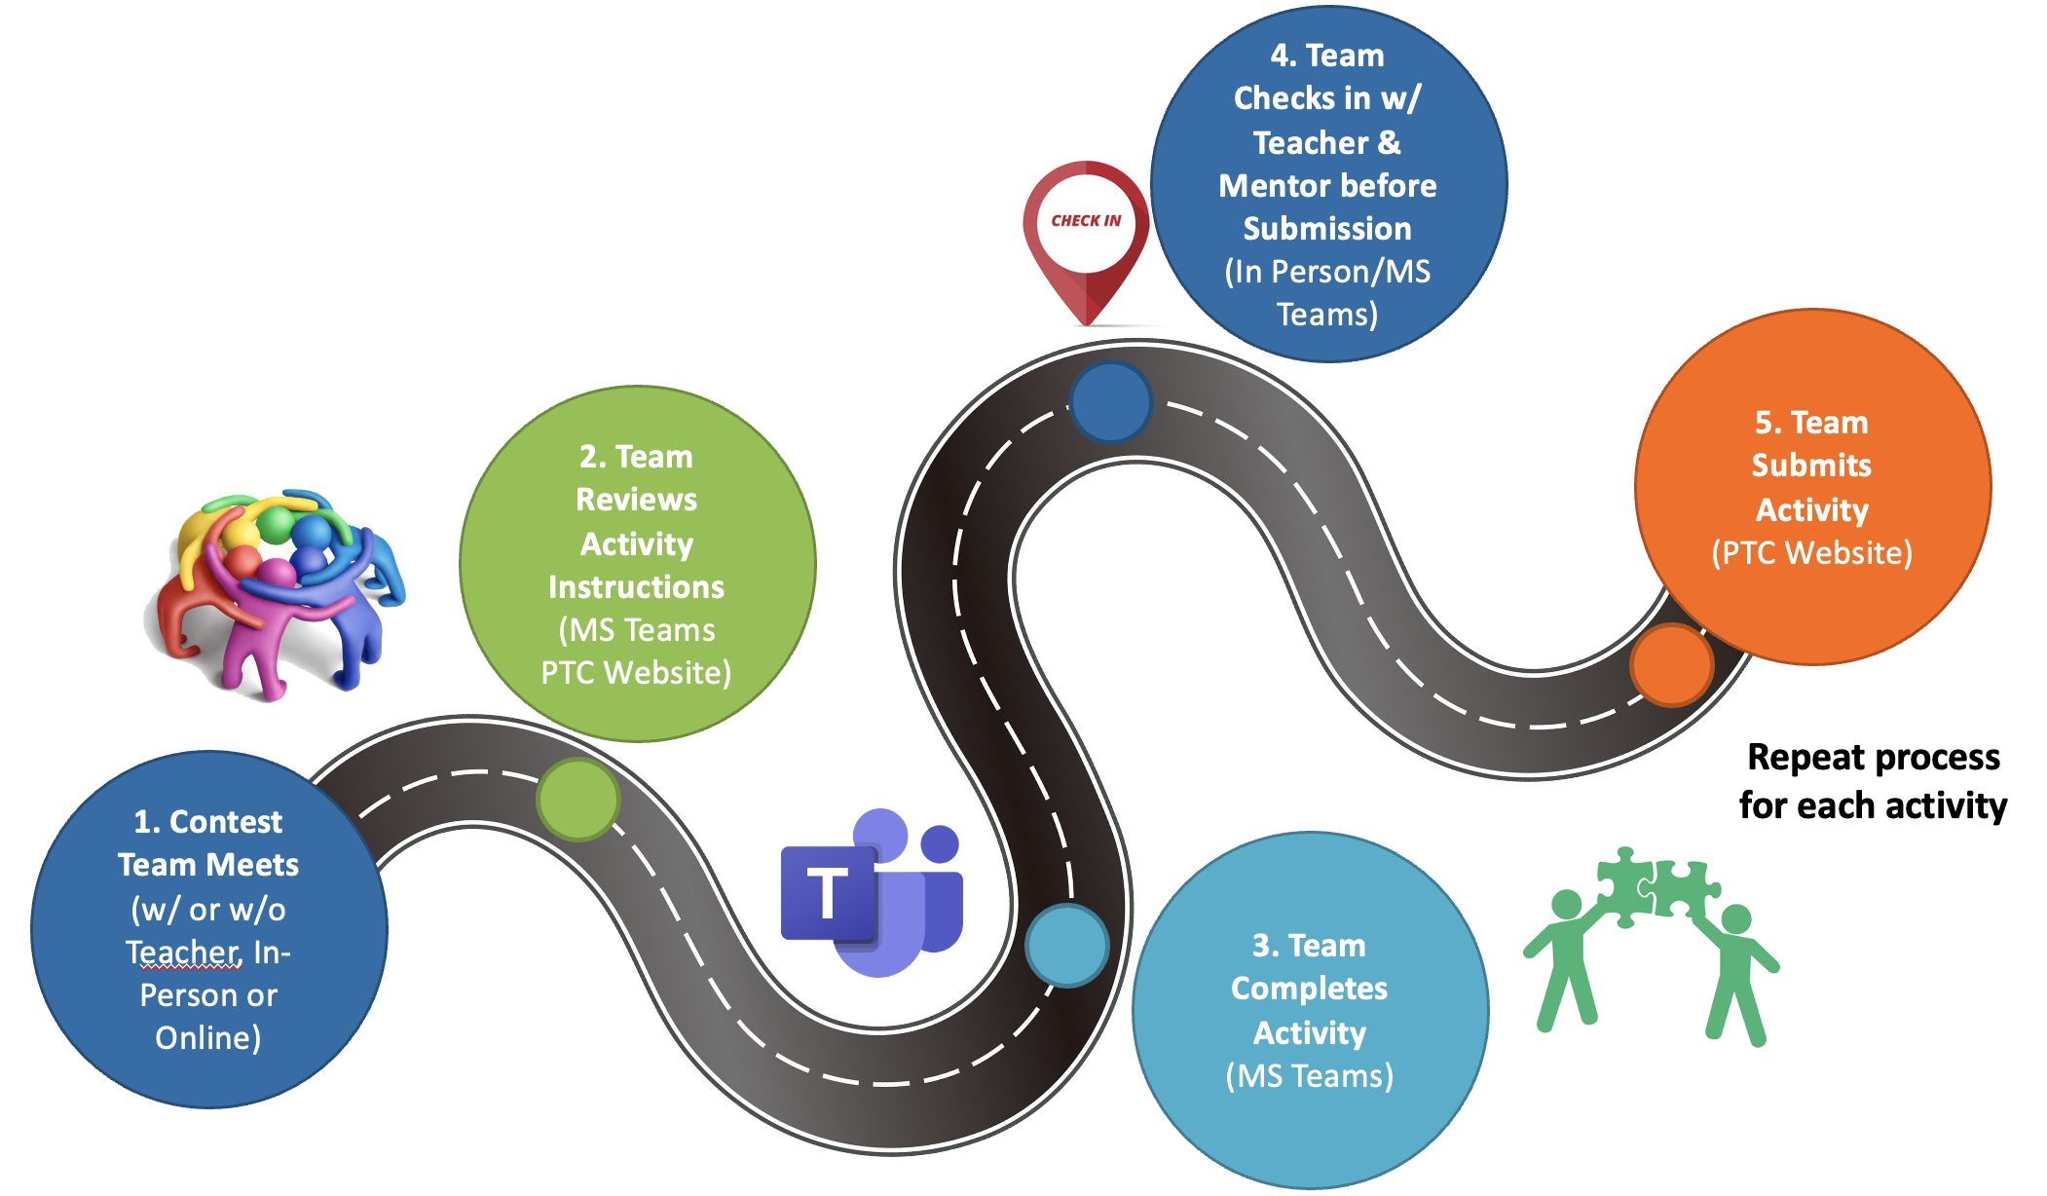

Team Workplan
Instructions: Create an official contest workplan for your team. First, decide how often you will meet in-person to work as a team. Then, choose which days of the week work best for everyone to meet. Finally, choose times of the day that your team can meet to work together.
- How many times a week will your team meet?
>
- Which days of the week will your team meet? Highlight them below.
Monday Tuesday Wednesday Thursday Friday
- What times of the day will your team meet?
>
Your mentor must virtually review each Activity before you turn it in on Friday. However, you can also pick a weekly day and time to meet with your mentor for a guided work session. Mentor meetings should be between Monday and Wednesday.
Instructions: Use virtual chat or meet with your mentor to determine a day and time that works best for everyone in your team and your mentor.
- Which day of the week will your team meet with your mentor? Highlight it below.
Monday Tuesday Wednesday
- What time of the day will your team meet with your mentor?
>

Instructions: Make your Team Work Plan official by entering it into a calendar. The blank calendar already includes the important contest deadlines.
Filling out your Team Work Calendar: Click a day in the blank calendar and write the details of your team work plan. While your cursor is in each box, use the paint bucket icon at the top of Word to highlight different scheduling items in different colors.
- Example: Highlight the days you will meet as a team each week in BLUE. Highlight the days you will meet with your mentor each week in GREEN. The important contest dates and due dates for each activity are already highlighted in RED.

Team Work Calendar
October 2025
MONDAY | TUESDAY | WEDNESDAY | THURSDAY | FRIDAY | SATURDAY | SUNDAY
29 | 30 | 1 | 2 | 3 | 4 | 5
 |  |  |  | Contest Kickoff
6 | 7 | 8 | 9 | 10 | 11 | 12
 | Activity 1 Submission |  | *Activity 2 Mentor Review | Activity 2 Submission
13 | 14 | 15 | 16 | 17 | 18 | 19
 |  |  | *Activity 3 Mentor Review | Activity 3 Submission
20 | 21 | 22 | 23 | 24 | 25 | 26
 |  |  | *Activity 4 Mentor Review | Activity 4 Submission
27 | 28 | 29 | 30 | 31 | 1 | 2
 |  |  | *Activity 5 Mentor Review | Activity 5 Submission

November 2025
MONDAY | TUESDAY | WEDNESDAY | THURSDAY | FRIDAY | SATURDAY | SUNDAY
3 | 4 | 5 | 6 | 7 | 8 | 9
 |  |  | *Activity 6A Mentor Review | Activity 6A Submission
10 | 11 | 12 | 13 | 14 | 15 | 16
 |  | Activity 6B  Submission |  | School Submits Top 2 Teams
17 | 18 | 19 | 20 | 21 | 22 | 23
Activity 7 Submission |  |  | PTC Design Showcase

Submit After Completion
- Ask your team’s mentor to check your work. Your team should make changes as needed.
- Save this document as a PDF with the title Activity 1_[Team Name].pdf and then have your Quality Engineer submit your PDF here: https://ufl.qualtrics.com/jfe/form/SV_eRiNCrlux5ALUKq

