Activity 1A: Understanding the Problem
Team Name:
Team Member Names:
Purpose:
- Team should use this activity to understand the technical context behind designing an AI-assisted home energy system that can achieve different design goals.
- Read an overview of the contest that explains the overall contest goals and procedures completed during each contest activity
- Complete background reading that familiarizes team with concepts needed to understand the contest goals and complete the different activities
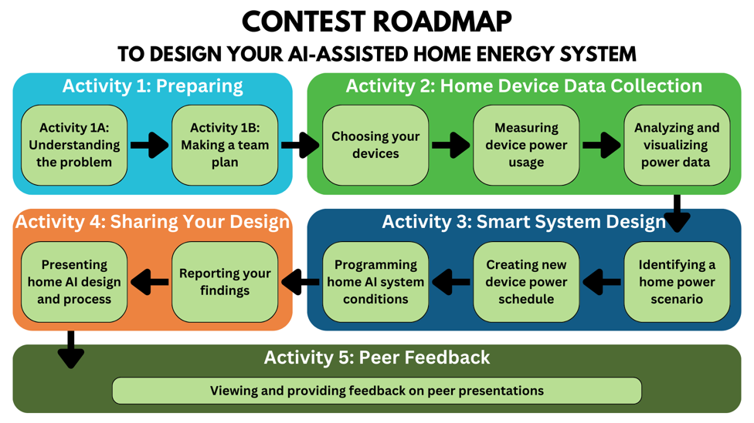
Activity Tutorial:
https://youtu.be/FEDgeN74t0g
Table of Contents
Part 1: Contest Overview 2
Part 2: Background Reading 3
Key Terms 4
Electricity and Power 4
Activity 2 6
Home Appliances and Devices 6
Monitoring Power Usage and Energy Consumption 6
Activity 3 8
Understanding Household Energy Consumption 8
Power Optimization 8
Smart Energy Management 9
Activity 4 10
What is “Artificial Intelligence”? 10
Part 3: Main Takeaways 11
Part 4: Submit Assignment 12
References 13

Part 1: Contest Overview

The goal of this contest is to design an AI-assisted system that can (1) optimize power usage, (2) reduce energy consumption, and/or (3) minimize the cost of electricity in your home. The contest has five activities that guide your team to design a home energy system. Each activity is worth one point, five points total. To earn a full point, your team needs to complete and submit the activities on time.
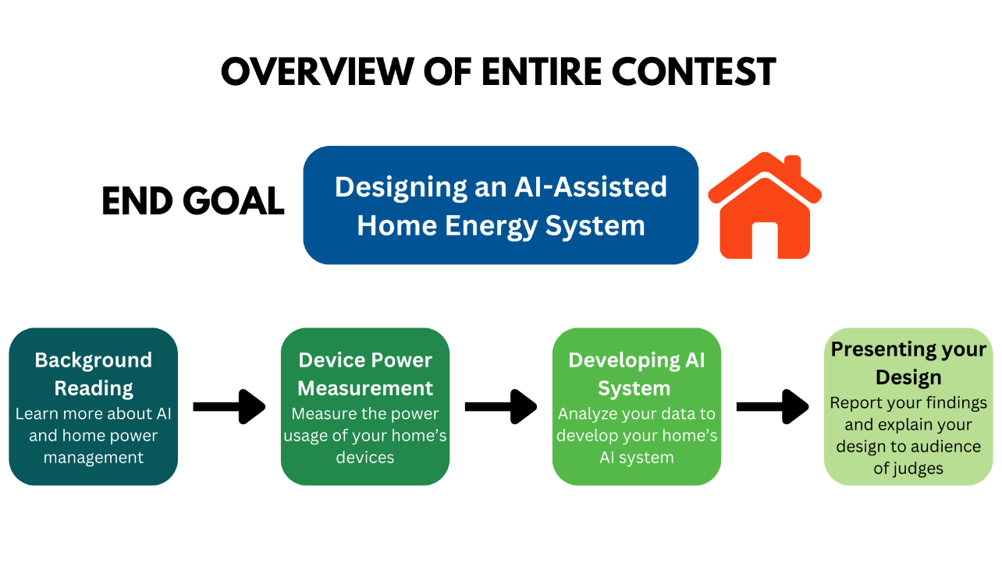

- In Activity 1, your team will begin by learning about different power, energy, and AI concepts. You will then assign team roles and make a work plan to decide how and when your team will work together on the other activities.
- In Activity 2, each member of your team will take turns using your team’s digital power monitor to collect data on the baseline power usage of the home devices you choose. Your team will work together to collect and analyze the data to create a home device power schedule.
- In Activity 3, your team will use your home device data to design an AI system that addresses a home scenario you choose by implementing a new power schedule.
- Finally, in Activity 4, you will summarize the work you have done, report your findings, and present your designed AI system.

Part 2: Background Reading

Instructions: Read the background information below. This will help you learn the key concepts of the contest so that you can understand your design process.

Key Terms

Circuit – A path for electricity that starts from a power source
Electricity – A type of energy found in different forms (positive or negative); electricity can form on its own or be made by people.
Power – A source of energy
System – A connected group of things that work individually and together
Energy Consumption – The amount of electricity and other types of energy that are used
Voltage – Electric strength measured in volts
Current – A movement of positive or negative electric particles (such as electrons) measured in amperes
Machine Learning – When a computer learns from data to make decisions without being specifically programmed

Electricity and Power

Gas, coal, solar energy, wind, and other sources can be used to produce electricity. Most of the electricity in the United States is generated using fossil fuels, such as coal, oil, and natural gas [1].
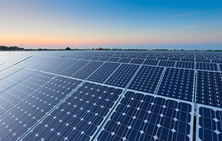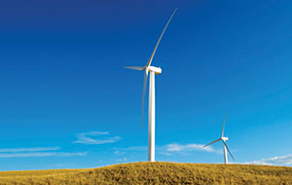
Copyright: https://www.duke-energy.com/energy-education/how-energy-works
Electricity is generated in power plants using different energy sources. Once it is generated, the electricity travels through big cables, from transmission lines to special stopping points called substations. From the substations, the electricity moves through more cables to reach users. When electricity travels, the amount of it that travels in a certain amount of time is called power. The substations help control how much electrical power from the power plants is divided among different user types through power lines [2]. Some user types are stores, schools, hospitals, and homes. The graphic below shows how electricity travels through these stages from power generators to homes.
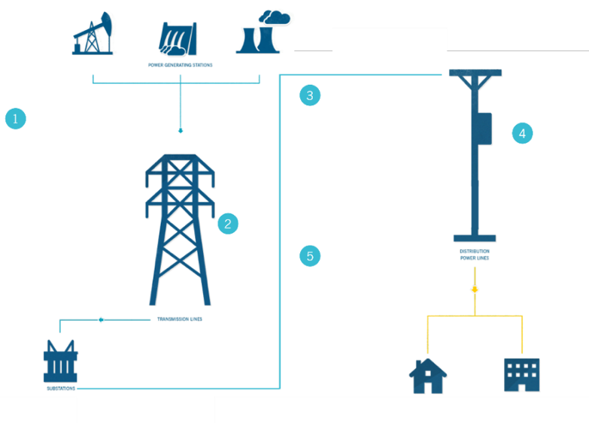
Copyright: https://www.duke-energy.com/energy-education/how-energy-works/delivering-electricity
Once it reaches your home, the electrical power received from power lines is then sent to different parts of the house through a collection of circuits. A circuit is like your circulatory system. Your blood vessels are like wires in a circuit. The vessels carry blood throughout your body to different organs. The wires in a circuit carry an electric current to different parts of an electrical system [3]. Circuits come in all different sizes. Your house is like one big, complicated system of circuits. Each household appliance or device is a part of the electrical system to which electricity and power are supplied. When a device is turned off, its circuits are open, and when you turn the device on, you close the circuit.

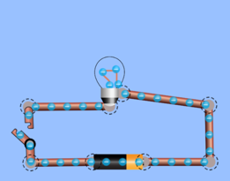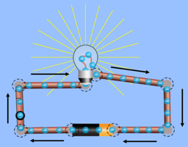
Open Circuit Closed Circuit
[4] Copyright: https://phet.colorado.edu/sims/html/circuit-construction-kit-dc/latest/circuit-construction-kit-dc_en.html

Activity 2

Home Appliances and Devices

Home appliances and devices use different amounts of power and energy when they are on and when they are off. There used to be a greater difference between the amount of energy an appliance uses when on and off. Now, some appliances/devices in a typical American household are always drawing power [5]. This means the amount of power a device or appliance draws while on or off could be very similar. Some appliances are always on. That said, household appliances and devices have become more energy efficient over time. They now use less energy and electricity to perform the same tasks as before.
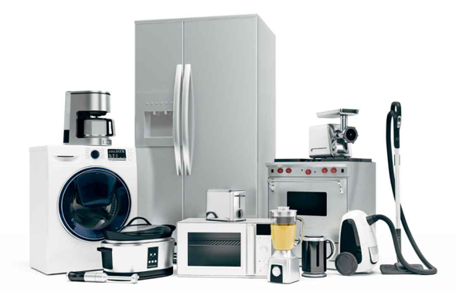
Copyright: https://thebetterappliances.com/wp-content/uploads/2024/06/1072-1.jpg

Monitoring Power Usage and Energy Consumption

There are tools that can monitor the energy consumption of appliances and devices in an electrical system. The data gathered from these tools can be used to create a plan for energy conservation. It is important that these tools are inexpensive and non-intrusive. A non-intrusive tool can monitor the power used by your home without having to access the electrical circuits built into the home’s walls and structure [6]. The measurement device you will be using for this project will measure the power usage of individual appliances/devices in a non-intrusive way.
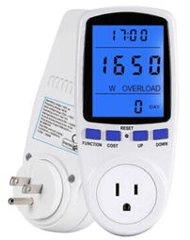
Copyright: https://i.ebayimg.com/images/g/CnwAAOSw3Khlp5VK/s-l400.jpg
The total amount of electricity that is provided to your home from energy companies is tracked using built-in meters.
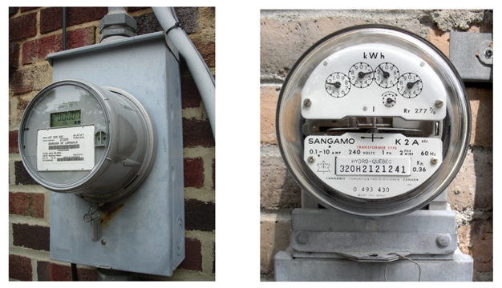
Copyright: https://upload.wikimedia.org/wikipedia/commons/7/7a/Elster_Type_R15_electricity_meter.jpeg
Copyright: https://upload.wikimedia.org/wikipedia/commons/b/b9/Hydro_quebec_meter.JPG

Within these meters, special sensors keep an eye on two important things: voltage (V) and current (I). Voltage is the difference in electrical potential, which is related to the difference in the concentration of electrical particles, between two places in a wire. These particles can be positive or negative [7], and this difference causes them to move. Current represents how much and in what direction these small electric particles are moving.
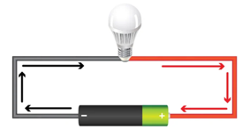
Copyright: https://dam-assets.fluke.com/s3fs-public/6004179-dmm-whatis-voltage-1500x1000.jpg
The power used by your home’s circuits is found by multiplying the voltage and current values of each circuit. So, your home’s built-in meters tell you how much power you are using by measuring how strong and fast the electricity is moving through the circuits.
$$P=V×I$$
Power represents the flow of energy per unit of time. Power (P) is measured in watts (W), and electric energy (E) is measured in watt-hours (W h). This means energy consumption over a period of time is equal to power multiplied by that time. The power usage and operating time data of your home’s appliances and devices can be used to find their total energy usage.
$$E=P×t$$
$$Whr=W×hr$$

Activity 3

Understanding Household Energy Consumption

When an appliance is used, electricity flows to the appliance to power it. This electricity is a form of energy that is converted into the appliance’s ability to do work that performs tasks. For example, when a refrigerator is given electricity, it cools your food. Electricity provided to your home by power plant substations is usually measured in kilowatt-hours (kWh), which is equal to 1000 watt-hours (Wh).
The average US household consumes about 11,000 kilowatt-hours of electricity per year [8]. This electricity is provided to houses by energy companies. These companies charge for the energy they supply. Florida’s Duke Energy’s typical residential customer, a single home, uses about 1,000 kW h of electricity per month and has a bill of $171.83 [9]. This is a rate of about 17 cents per kilowatt-hour of electricity. So, the more energy a household uses, the higher their electric bill will be. This is a big reason why power efficiency and preventing energy waste is important. Saving energy saves money.

Power Optimization

Power optimization is the use of automated tools to minimize power and energy waste [10]. This can be accomplished in many ways and with different technologies. Smart power strips reduce the energy that is wasted when electronics are plugged in and not in use.
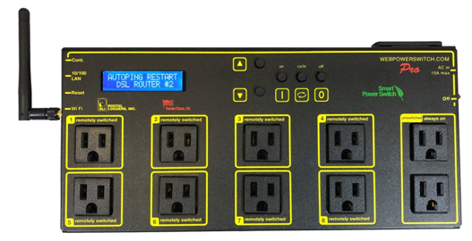
Copyright: https://m.media-amazon.com/images/I/61YvqWk1OuL._SL1082_.jpg
LED lights are more energy efficient than fluorescent and incandescent light bulbs, which waste more energy by giving off more heat to produce the same amount of light.
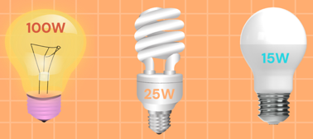
Proper roof and window insulation is important when it comes to heating and air conditioning [11]. These technologies can all lead to less energy being transferred to the outside environment. This means your heating, ventilation, and air conditioning (HVAC) unit, for example, will use less energy to keep the house at a desired temperature.
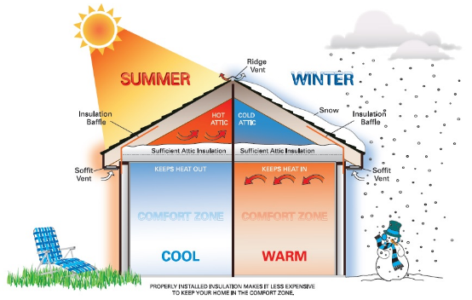
Copyright: https://www.energy.gov/energysaver/reducing-electricity-use-and-costs

Smart Energy Management

Smart energy management systems can help users automatically control the power usage, energy consumption, and therefore the cost of electricity in their homes. For example, different smart technology products can be used to track how your devices operate and then remotely manage them from a phone application. This way, your devices can be programmed to act on a schedule. Smart systems can also detect and provide alerts about issues in appliance and device performance [12]. A common example of a technology used in a household smart system is a smart thermostat. A smart thermostat can monitor and adjust the temperature of a home on its own, based on changes in weather and the time of day, and this reduces energy usage when your HVAC system is not needed. HVAC systems consume more energy than any other appliances in the home, so having a smart thermostat is very helpful for saving money and energy. Artificial intelligence can play a role in how accurately these smart appliance systems can operate.
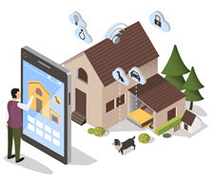
Copyright: https://www.energystar.gov/products/smart_home_energy_mgnt_systems
Artificial Intelligence (AI) can be used to optimize power usage in households by automatically controlling your smart system. Using AI, an interconnected system of household devices, such as smart power strips, lighting fixtures, or even an HVAC thermostat, can be automatically operated to adjust your home’s total energy consumption, based on when and how often you actually need the devices to be on or off. This ensures the most efficient use of energy without changes to the desired tasks you need your devices to perform.

Activity 4

What is “Artificial Intelligence”?

Artificial intelligence is the ability of a computer to also do tasks that humans can do. AI has gained popularity in recent years, and it is now being used in many fields to solve complex problems. Commonly, AI is used for face recognition, personal assistants, to customize social media, and in smart appliances.
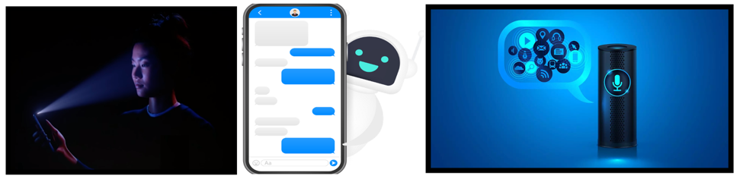 Copyright: HTTPS://EDGY.APP/WP-CONTENT/UPLOADS/2020/10/APPLE-FACEID-TECHNOLOGY-REVEAL-DURING-THE-IPHONE.PNG
Copyright: HTTPS://WWW.SEARCHENGINEJOURNAL.COM/WP-CONTENT/UPLOADS/2019/08/F322B4E3-885E-4AC1-98BF-587A69B2A1B9.JPEG

The internet of things (IoT) is a network of physical devices that are embedded with sensors and network connectivity that allows them to collect and share data. IoT systems allows these smart devices to talk to each other, exchange data, and perform tasks on their own. There are many ways to automate appliances with an IoT system in your household [13]. An example of an IoT device that can be used to manage appliances is a smart plug, which automatically turns appliances and devices “on” or “off” by sensing different conditions related to a schedule for when you typically use them.
AI in home energy systems can use the sensor data from connected devices to make energy management better for the residents. Certain AIs rely on machine learning. Machine learning is the use of continuously collected data to imitate the way that humans learn. This allows smart systems to gradually improve their accuracy as AI analyzes patterns in the data it collects with sensors. Data can be analyzed by AI in real time to optimize the appliances operations and improve their performance [14].
This contest will lead your team through the process of analyzing power usage data so that you can design and model how your own home energy system will make smart decisions. At the end of the contest, you will make a presentation that explains how AI can be used to improve the energy efficiency of your home based on the data you collected from the devices in your home.

Part 3: Main Takeaways

Instructions: Answer the following questions based on the concepts you learned in the background reading.

- What are some common sources of electricity?
>
- Using the diagram from the background reading, describe the path electricity takes from the power plants to your house.
>
- If the power measured in a circuit is 60 kW, how much energy will be used over a period of 4 hours? Include units in your answer.
>
- How much would this amount of energy cost for a typical Florida residential customer? Duke Energy charges a rate of 17 cents per kilowatt-hour of electricity.
>
- What is power optimization?
>
- What are some examples of a smart appliance?
>
- What is the Internet of Things (IoT)?
>
- How could IoT devices be helpful when using AI for household power optimization?
>

Part 4: Submit this Activity

- Meet with your team’s mentor to check your work and make changes as needed.
- Save this document as a PDF with the title Activity_1A_[Team Name].pdf
- Have your Quality Engineer submit your PDF here:
https://ufl.qualtrics.com/jfe/form/SV_eQaBRiCJA8MfQUe

References

Electricity and Power
[1] “Duke Energy Corporation,” Duke Energy, 2020. https://www.duke-energy.com/energy-education/how-energy-works
[2] “Duke Energy Corporation,” Duke Energy, 2020. https://www.duke-energy.com/energy-education/how-energy-works/delivering-electricity
[3] Sidney Soclof, “How Circuits Work,” HowStuffWorks, Jan. 21, 2008. https://science.howstuffworks.com/environmental/energy/circuit.htm (accessed Dec. 21, 2023).
[4] Phet Interactive Simulations, “Circuit Construction Kit: DC,” Colorado.edu, 2019. https://phet.colorado.edu/sims/html/circuit-construction-kit-dc/latest/circuit-construction-kit-dc_en.html‬
Home Appliances and Devices
[5] T. Schlossberg, “Just How Much Power Do Your Electronics Use When They Are ‘Off’?,” The New York Times, May 07, 2016. Available: https://www.nytimes.com/2016/05/08/science/just-how-much-power-do-your-electronics-use-when-they-are-off.html
Monitoring Power Usage and Energy Consumption
[6] H. Murata, “Estimation of power consumption for household electric appliances | IEEE Conference Publication | IEEE Xplore,” ieeexplore.ieee.org. https://ieeexplore.ieee.org/abstract/document/1201903?casa_token=HZa1DhzJMWYAAAAA:E58Qe_WP-EcsDicLKh80QE-eurF3PG_FYPH4bvgPSbtaVSHHMicWkpIyBWVaYLeEojycp3cG (accessed Dec. 21, 2023).
[7] “What are smart meters? | IBM,” www.ibm.com. https://www.ibm.com/topics/smart-meter#:~:text=For%20electricity%20meters%2C%20sensors%20measure%20the%20voltage%20and (accessed Dec. 21, 2023).
Understanding Household Energy Consumption
[8] EIA, “Use of energy in explained - U.S. Energy Information Administration (EIA),” Eia.gov, 2016. https://www.eia.gov/energyexplained/use-of-energy/
[9] D. Energy, “Regulators approve Duke Energy Florida’s fuel, capacity and storm restoration costs, easing customer bill impacts,” Duke Energy | News Center, 2023. https://news.duke-energy.com/releases/regulators-approve-duke-energy-floridas-fuel-capacity-and-storm-restoration-costs-easing-customer-bill-impacts#:~:text=%E2%80%93%20Today%2C%20the%20Florida%20Public%20Service%20Commission%20%28FPSC%29 (accessed Dec. 21, 2023).
Power Optimization
[10] J. Batani, Silence Dzambo, and I. Magodi, “Household Power Optimisation and Monitoring System,” International Journal of Computer Science and Business Informatics, vol. 17, no. 2, Jan. 2018.
[11] “Reducing Electricity Use and Costs,” Energy.gov. https://www.energy.gov/energysaver/reducing-electricity-use-and-costs
Smart Energy Management
[12] “Smart Home Energy Management Systems,” www.energystar.gov. https://www.energystar.gov/products/smart_home_energy_mgnt_systems
What is “Artificial Intelligence”?
[13] IBM, “What is the internet of things?,” www.ibm.com, Oct. 01, 2015. https://www.ibm.com/topics/internet-of-things
[14] IBM, “What is Machine Learning?,” IBM, 2023. https://www.ibm.com/topics/machine-learning

