Activity 7: Design Showcase Proposal Presentation
Team Name:
Team Member Names:
Purpose:
- Modify your design proposal PowerPoint based on feedback from your teacher, mentor, and peers
- Practice your proposal presentation with your teacher and mentor
- Make final refinements for the PTC Design Showcase!
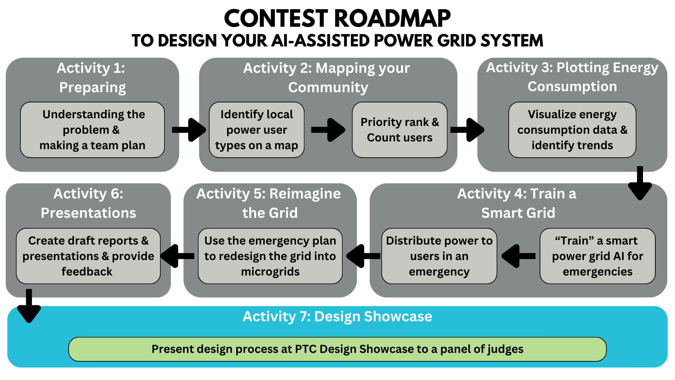
Instructions:
To demonstrate your team’s design thinking process applying artificial intelligence (AI) to a smart microgrid system, your team must be able to justify your design of the product to your stakeholders and/or the company’s leadership team in a professional setting. On November 20th, you will propose your smart grid design to a panel of power industry experts from Duke Energy Florida.
The panel will be listening for:
- Your reasoning behind each stage of your smart grid design
- How your grid design prioritizes the needs of your community’s users
- How your smart system supports your community during outages
- How AI is used to improve your design
Remember, your main objective is to effectively communicate all the factors used to design your intelligent system. In this contest, your entire design process represents an intelligent system through which you decided how power will be distributed to your community through a smart microgrid system.
Check the rubric you received in Activity 6A to make sure different parts of your presentation are in line with what the judges will be looking for:
Rubric Criteria for Proposal Presentation
Category | Criteria | Score (0-5)
Design | - Responds to all prompts and includes all outlined components  - Clearly demonstrates data-driven understanding of your community’s users, power needs, and priorities  - Clearly guides the audience through the logic behind your design process  - Decisions and conclusions are appropriate, well-communicated, and apply to the context of the design.  - Information included is relevant and accurate.  - Answers to follow-up questions are supported by insights related to your community and unique design.
Delivery | - Presentation slides are clear.  - All group members speak during the presentation.  - Presentation is engaging, polished, and well-rehearsed.  - Explanations are clear, coherent, and consistent.  - Reasoning is organized, connected, and flows well.
Depiction | - Adheres to outlined formatting:  - Includes Team Name, Team Member Names, School Name, Teacher Name, Mentor Name, Presentation Title, Numbered Slides  - Presented Title, Tables, and Graphs are well organized on the slide and include proper labels with capitalization.  - IEEE References are correctly formatted and numbered on a reference slide, with citations as needed on proper slides.  - Always uses appropriate language  - Edited for no spelling, punctuation, or grammatical errors  - Easy to read and understand images and text on slides  - Stylistic choices such as background or font do not detract from presentation

Considering the feedback you received from other teams, revise your presentation and plan out how your group will facilitate presenting your design to the panel of experts.
Before submitting your final presentation draft on November 18th, you must meet with your teacher and mentor to practice your presentation. Use this opportunity to gain feedback on not only your slides but your presentation as a whole.
Design Showcase Presentation Requirements
- Your presentation should be about 10 minutes, followed by up to 5 minutes for questions from the judges and audience. Your team cannot exceed 15 minutes.
- Each team member must introduce themselves and their role.
- Everyone on your team must speak during the presentation.

Dress Code and Etiquette:
- Please wear business causal clothing for your presentations.
  - For men this includes a collared or button-down shirt with slacks.
  - For women this includes a blouse with slacks or an appropriate skirt/dress.
- Please refrain from wearing jeans or leggings.
- Sneakers/closed-toed shoes are acceptable for footwear; dress shoes are a plus.
- Remember to speak clearly and make eye contact with members of the audience.
  - Try not to mumble or speak too quickly!
- Allow all members of your team to speak throughout the presentation
  - Try not to interrupt each other!
  - Think about your different team roles and defer to each other when one of you is best positioned to answer a certain question.

Final Proposal Presentation submission:
- Meet with your team, mentor, and teacher to make sure your presentation is completely ready for the Design Showcase.
- Save the final draft of your presentation as a PowerPoint file with the title Activity_7_Proposal_[Team Name].pptx and then have your Quality Engineer submit your PowerPoint here: https://ufl.qualtrics.com/jfe/form/SV_3wwsZbxwqu39mK2

