Activity 6B: Proposal Feedback
Team Name:
Team Member Names:
Purpose:
- Collaboration is key to a successful project! Teams will provide and receive feedback to prepare them for the Design Showcase.
- Teams will review and give feedback on the draft proposals submitted by two other teams.
- Teams will consider the feedback from other teams to later incorporate final edits into their proposal.
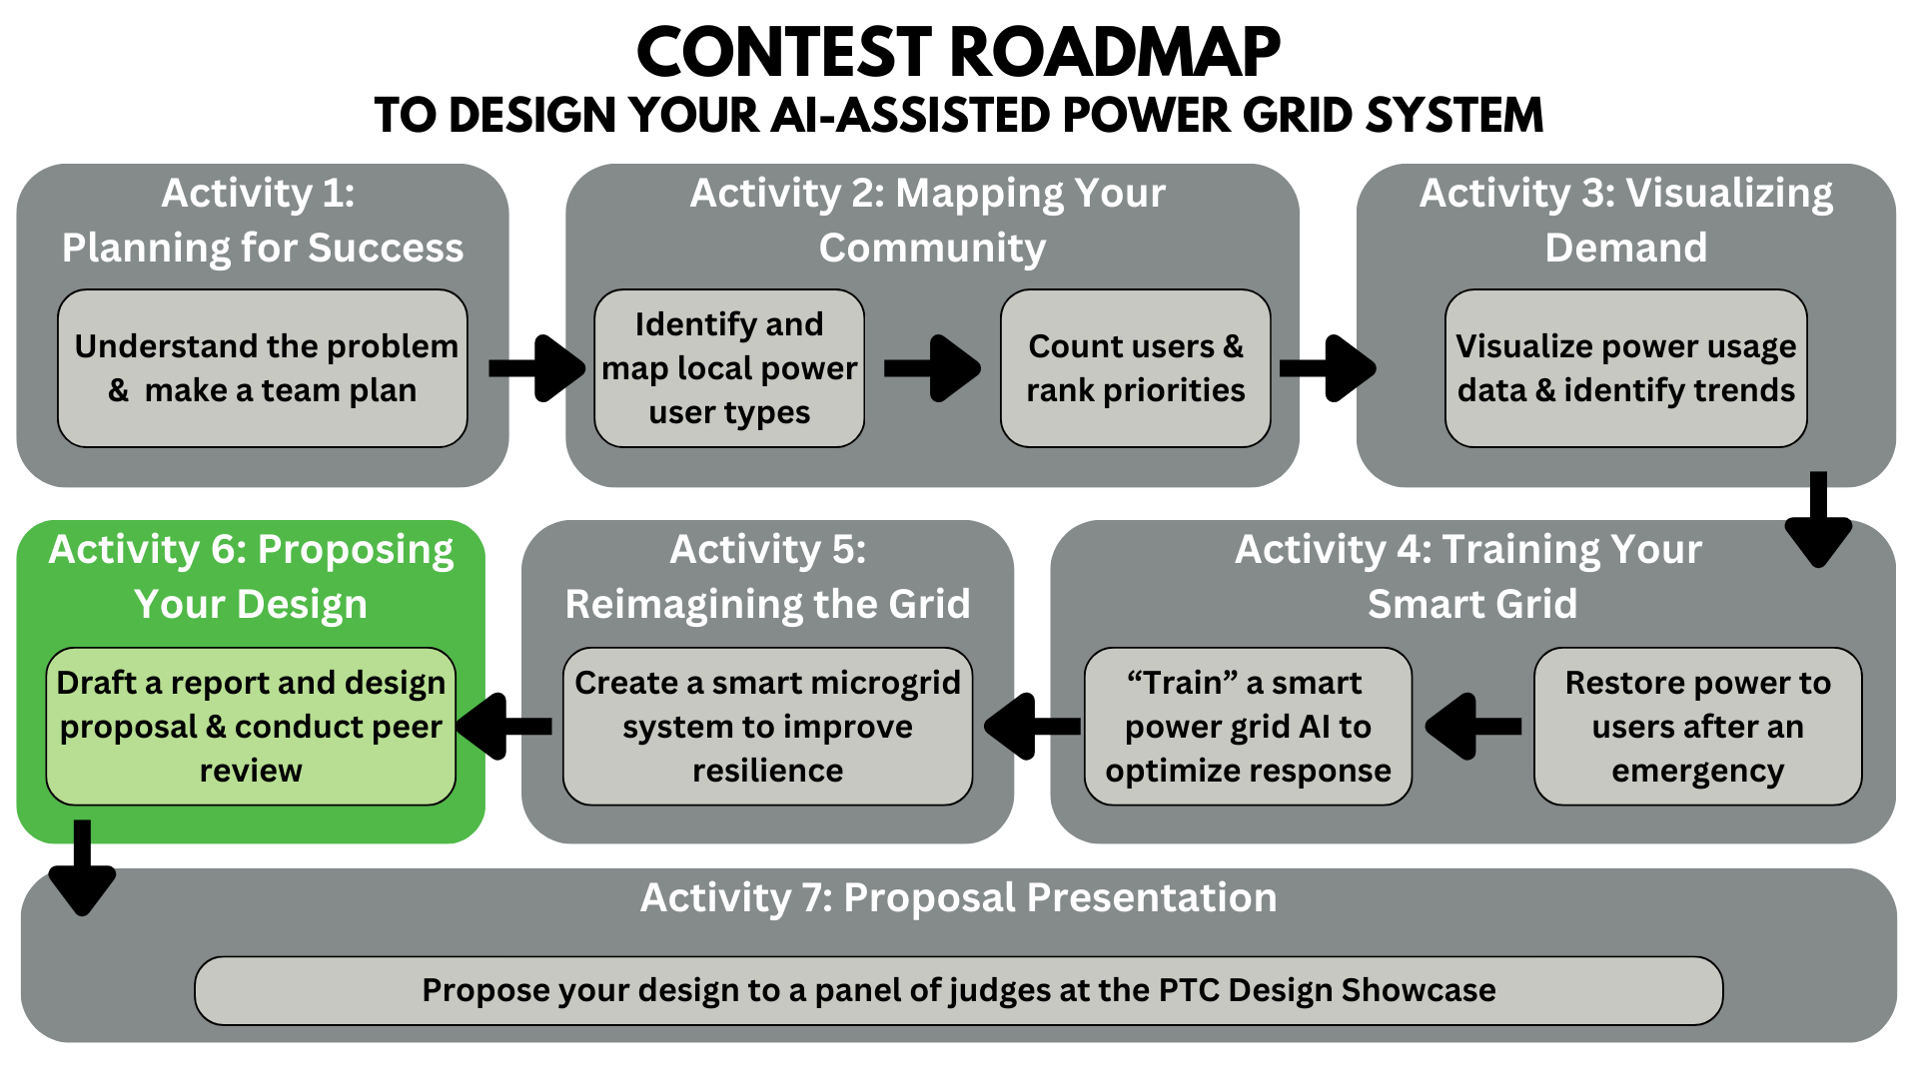
Activity Tutorial: https://youtu.be/K8s-BKU9XuM

Peer Feedback Rubric (Proposal)

Category | 5 – Above Standard | 4 | 3 - Standard | 2 | 1 – Below Standard
Presentation | No extra information on the slides. No distracting images or fonts. No long paragraphs on slides. Presentation is within the limit (5 to 7 minutes). The font is easy to read. |  | Little extra information on slides. Few distracting images or fonts. Few long paragraphs on slides. Presentation is less than 1 minute away from the limit (4 – 4:59 or 7:01-8 minutes). Font can be read. |  | Unnecessary information on slides. Some distracting images or fonts. Some long paragraphs on slides. Presentation is more than 1 minute away from the limit. The font is hard to read.
Content | Design choices are clearly justified. The design process and design are clearly explained. The proposal is well-thought-out. |  | Design choices are somewhat justified. The design process and design are explained. The proposal has minor issues. |  | Design choices are not justified. The design process and design are not explained. The proposal has major issues.
Organization | The presentation flows in a way that makes sense. Enough background information is given for the audience to understand the presentation. |  | The presentation has some order. Some background information is given for the audience to understand the presentation. |  | The presentation is hard to follow and confusing. Little to no background information is given for the audience to understand the presentation.
Mechanics | All sources are cited in a single format. There are no spelling or grammatical errors. |  | Some sources are not cited, or different formats are used. There are some spelling or grammatical errors. |  | Sources are not cited. There are many spelling or grammatical errors.

Instructions: Complete one table below for each team you are evaluating. In the table, provided a score from 1–5 for each category and justify your score. Give at least 3 constructive comments.
Ex. constructive comments:
“When you discussed… I liked that you…”
“In the section about… I think it would be clearer if you…”
Ex. unhelpful comments:
“That was bad.”
“I liked it.”

Student Team Peer Feedback

Team 1
Your Team Name:
Team Receiving Feedback:
Category | Score | Justification
Presentation
Content
Organization
Mechanics
Comments:

Team 2
Your Team Name:
Team Receiving Feedback:
Category | Score | Justification
Presentation
Content
Organization
Mechanics
Comments:

Submit After Completion
- Save this document as a .doc file with the title Activity_6B_Feedback_[Team Name].pdf
- Submit the PDF here: https://ufl.qualtrics.com/jfe/form/SV_eRiNCrlux5ALUKq

