Activity 6A: Proposing Your Design
Team Name:
Team Member Names:
Purpose:
- Teams will organize the design strategies they have developed throughout the first five activities into an executive summary and final presentation.
- In the presentation, teams will provide the narrative outlining their process to (1) assess their community and its power needs, (2) train a smart grid system in the event of an emergency outage, and (3) design a reimagined microgrid system.
- Teams should use this activity to synthesize what they have learned into clearly communicated insights regarding their design of a smart microgrid system.
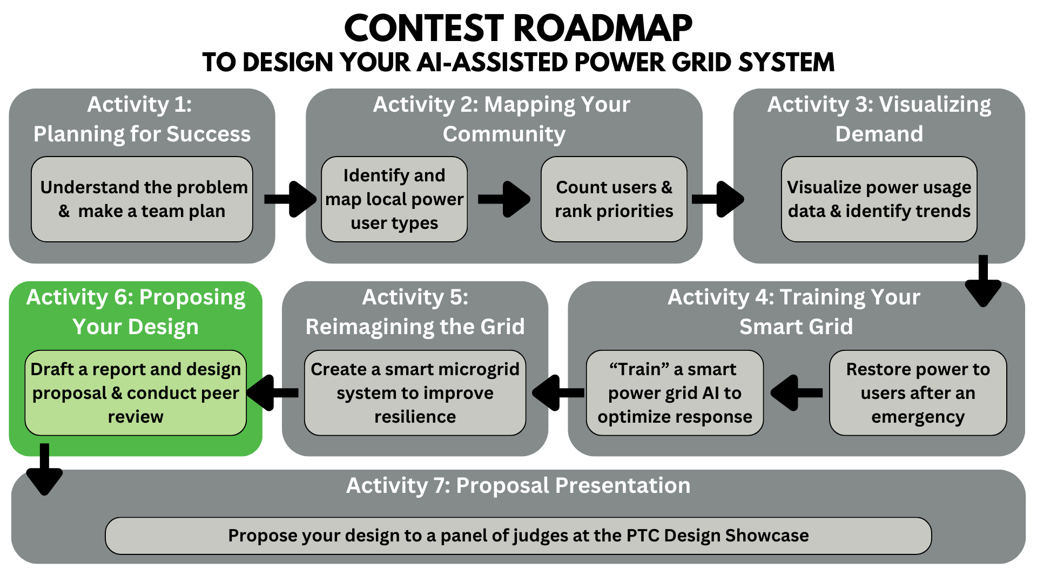
Activity Tutorial: https://youtu.be/9bdwuDc_1N0

Table of Contents
Part 1: Reporting Your Findings – Executive Summary 2
Part 2: Design Proposal – PowerPoint Presentation 3
Rubric - Design Proposal Presentation 4
After Completion 8

Part 1: Reporting Your Findings – Executive Summary

Instructions: In 3 pages or less, write an executive summary discussing (1) the energy landscape of your community, (2) how the data your team analyzed led you to make decisions for training your AI power grid system in the event of an emergency outage, and (3) how your understanding of your community’s power usage led you to construct a reimagined microgrid system. This executive summary should review, synthesize, and expand upon justifications your team developed while completing Activities 1–5.
Use the “6A_Executive Summary Outline” Word document as a template with more detailed information on what to include in your executive summary and how to structure it. You can write your executive summary directly into that document, as it is already properly formatted.
Your executive summary should provide enough detail to accomplish the following main goals:
- Explain how mapping your community provides an understanding of the distribution of different power users, and how you developed different priorities.
- Explain how different power trends in your community are quantified and visualized.
- Explain how analyzing power consumption data helped you train your AI to optimize a response to power outages.
- Explain how you designed a system of microgrids to protect your community from outages.
- Explain future considerations, possible scenarios, and how improvements could be made to enhance the microgrid system with AI.
A primary purpose of the executive summary is to provide the contest judges with a concise resource that helps them contextualize and recall your presented proposal.
Saving your Executive Summary
After you have finished writing your executive summary, save it as a PDF file named “Activity_6A_ES_Draft_[Team Name].pdf”. You will submit this file using the submission instructions at the end of this document.

Part 2: Design Proposal – PowerPoint Presentation

Instructions: Create a PowerPoint presentation that constructs a narrative walking your audience (your peers and the judges!) through the different stages and justifications of your entire smart grid design process. Emphasize how insights you obtained from mapping and analyzing the data for users in your community led you to develop different user priorities. Demonstrate how you were able to optimize power restoration with the snapshots you used to train your AI. Finally, explain how you developed your microgrid system and would incorporate AI to create a resilient smart grid for your community.
Your proposal presentation should include key points from your executive summary but also discuss your design process in more detail by providing more visual examples that represent your community and demonstrate your reasoning.
For more detailed information on what to include in your proposal presentation and how to structure it, use the “6A_Proposal Template.pptx” PowerPoint. You can complete your presentation directly in that PowerPoint, but make sure to follow instructions to delete the instructional slides once you have completed your presentation.
You must use PowerPoint to create your presentation.
Saving your Design Proposal Presentation Draft
After you have finished creating your Design Proposal PowerPoint, save it as a PDF file named “Activity_6A_Proposal_Draft_[Team Name].pdf”. You will submit this file using the submission instructions at the end of this document.

Rubric - Design Proposal Presentation

As you create the slides for your presentation, check the rubric criteria below to make sure you’re meeting or exceeding all the requirements for effectively communicating your design. This rubric will be used by the judges to evaluate and score your proposal at the Design Showcase! For more detailed information about how your presentation will be judged, read through the rubric breakdowns that follow.

Rubric Criteria for Proposal Presentation
Category | Criteria | Score (0-5)
Design | - Responds to all prompts and includes all outlined components  - Clearly demonstrates data-driven understanding of your community’s users, power needs, and priorities  - Clearly guides the audience through the logic behind your design process  - Decisions and conclusions are appropriate, well-communicated, and apply to the context of the design.  - Information included is relevant and accurate.  - Answers to follow-up questions are supported by insights related to your community and unique design.
Delivery | - Presentation slides are clear.  - All group members speak during the presentation.  - Presentation is engaging, polished, and well-rehearsed.  - Explanations are clear, coherent, and consistent.  - Reasoning is organized, connected, and flows well.
Depiction | - Adheres to outlined formatting:  - Includes Team Name, Team Member Names, School Name, Teacher Name, Mentor Name, Presentation Title, Numbered Slides  - Presented Title, Tables, and Graphs are well organized on the slide and include proper labels with capitalization.  - IEEE References are correctly formatted and numbered on a reference slide, with citations as needed on proper slides.  - Always uses appropriate language  - Edited for no spelling, punctuation, or grammatical errors  - Easy to read and understand images and text on slides  - Stylistic choices such as background or font do not detract from presentation

Design Rubric Breakdown
Design (5): | Design (4): | Design (3): | Design (2): | Design (1): | Design (0):
Responds to all prompts and follows all outlined reminders. | Responds to all prompts and follows most outlined reminders. | Responds to most prompts and follows most outlined reminders. | Responds to most prompts and follows some outlined reminders. | Responds to some prompts and follows some outlined reminders. | Does not respond to any prompts and follow any outlined reminders.
Clearly documented data-driven design. | Documented data-driven design. | Sometimes documented data-driven design. | Sometimes documented data-driven design. | Rarely documented data-driven design. | Did not document data-driven design.
Clearly explains design process. | Explains design process. | Somewhat explains design process. | Somewhat explains design process. | Attempts to explain design process. | Does not explain design process.
Decisions and conclusions always are appropriate, understandable, and make sense. | Decisions and conclusions always are appropriate, understandable, and make sense. | Decisions and conclusions mostly are appropriate, understandable, and make sense. | Decisions and conclusions sometimes are appropriate, understandable, and make sense. | Decisions and conclusions sometimes are appropriate, understandable, and make sense. | Decisions and conclusions are not appropriate, understandable, and do not make sense.
Information included is always relevant and correct. | Information included is always relevant and correct. | Information included is mostly relevant and correct. | Information included is sometimes relevant and correct. | Information included is rarely relevant or correct. | Information included is not relevant or correct.

Delivery Rubric Breakdown
Delivery (5): | Delivery (4): | Delivery (3): | Delivery (2): | Delivery (1): | Delivery (0):
Presentation slides are always clear. | Presentation slides are always clear. | Presentation slides are mostly clear. | Presentation slides are sometimes clear. | Presentation slides are rarely clear. | Presentation slides are not clear.
All group members speak during the presentation. | All group members speak during the presentation. | All group members speak during the presentation. | All group members speak during the presentation. | Not all group members speak during the presentation. | Not all group members speak during the presentation.
Presentation is always engaging, polished, and well-rehearsed. | Presentation is mostly engaging, polished, and well-rehearsed. | Presentation is mostly engaging, polished, and well-rehearsed. | Presentation is sometimes engaging, polished, and well-rehearsed. | Presentation is rarely engaging, polished, and well-rehearsed. | Presentation is not engaging, polished, and well-rehearsed.
Explanations are always clear, coherent, and consistent. | Explanations are mostly clear, coherent, and consistent. | Explanations are sometimes clear, coherent, and consistent. | Explanations are rarely clear, coherent, and consistent. | Explanations are not clear, coherent, and consistent. | Explanations are not clear, coherent, or consistent.
Information is always organized, connected, and flows well. | Information is always organized, connected, and flows well. | Information is mostly organized, connected, and flows well. | Information is sometimes organized, connected, and flows well. | Information is rarely organized, connected, and flows well. | Information is not organized, connected, or flows well.

Depiction Rubric Breakdown
Depiction (5): | Depiction (4): | Depiction (3): | Depiction (2): | Depiction (1): | Depiction (0):
Adheres to all outlined formatting guidelines. | Adheres to all outlined formatting guidelines. | Adheres to all outlined formatting guidelines. | Missing 1-2 outlined formatting guidelines. | Missing 3-4 outlined formatting guidelines. | Missing all outlined formatting guidelines.
Always uses appropriate language. | Always uses appropriate language. | Mostly uses appropriate language. | Mostly uses appropriate language. | Sometimes uses appropriate language. | Does not use appropriate language.
No spelling, punctuation, or grammatical errors. | Few spelling, punctuation, or grammatical errors. | Some spelling, punctuation, or grammatical errors. | Many spelling, punctuation, or grammatical errors. | Constant spelling, punctuation, or grammatical errors. | Constant spelling, punctuation, or grammatical errors.
Easy to read and understand. | Easy to read and understand. | Easy to read or understand. | Hard to read or understand. | Hard to read and understand. | Hard to read and understand.
Stylistic choices such as background/font never detract from presentation. | Stylistic choices such as background/font rarely detract from presentation. | Stylistic choices such as background/font rarely detract from presentation. | Stylistic choices such as background/font sometimes detract from presentation. | Stylistic choices such as background/font detract from presentation. | Stylistic choices such as background/font detract from presentation.

Submit After Completion

- Meet with your team’s mentor to check your work and make changes as needed.
- Make sure your Executive Summary draft and your Proposal Presentation draft are each saved as a PDF.
- Submit your two PDFs in the same survey: https://ufl.qualtrics.com/jfe/form/SV_eRiNCrlux5ALUKq
  - Attach Activity_6A_ES_Draft_[Team Name].pdf
  - Attach Activity_6A_Proposal_Draft_[Team Name].pdf

